**NEWS RELEASE**

**COBBLESTONE HOTELS, LLC OPENS LYNDEN, WASHINGTON.**

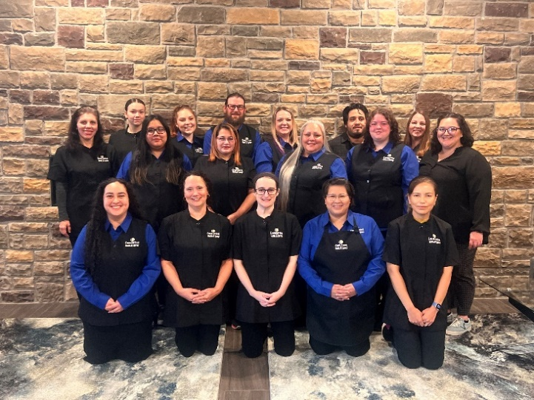**October 29, 2024– Neenah, WI –** Cobblestone Hotels announces the opening of the Cobblestone Hotel & Suites in Lynden, Washington. This 68-guestroom hotel is located at 8155 Guide Meridian Road in the city of Lynden, near the major highway WA-539.   
  
Lynden is located 15 miles North of the city of Bellingham, WA and less than 20 minutes from the United States – Canadian border. Lynden’s more rural location offers a welcome retreat for those who are looking for lodging near to many key businesses and industries, but still wanting to enjoy the pace and charm of a smaller city.   
  
Guests at the Cobblestone Hotel & Suites will find opportunities to explore this section of northwestern Washington, through recreation, industry and history. Local businesses in the manufacturing, construction, and agricultural sectors can be found throughout the city. The Cobblestone Hotel & Suites is just minutes from downtown Lynden, which is the city’s thriving cultural center featuring entertainment and event centers such as the Claire Theatre, Jansen Art Center, Pioneer Museum, and Northwest Washington Fairgrounds.   
  
The Cobblestone Hotel & Suites – Lynden offers guests classic Cobblestone amenities like coffee and tea makers, mini-refrigerators, microwaves, and flat-screen televisions in every room. A complimentary hot breakfast is offered each morning, and high-speed internet access can be found throughout the hotel. Complimentary Starbucks coffee is featured 24/7 in the lobby as well as in each guestroom. Onsite services such as coin-operated guest laundry, a business center with a computer and printer, an indoor swimming pool, and an onsite exercise facility are available for all who choose to Stay Cobblestone while visiting Lynden. Guests will also be able to enjoy an unforgettable meal at the hotel’s onsite restaurant, the Wissota Chophouse, which will be opening soon on the ground floor of the hotel.

Whether you are travelling for business or leisure, when you stay Cobblestone, you will experience the “Big City Quality.... Small Town Values” that each location has to offer. Visit [www.staycobblestone.com](http://www.staycobblestone.com/) for reservations and more.

Follow us on Facebook to stay up to date on all our new and upcoming locations at <https://www.facebook.com/cobblestonehotels/>   
  
**About Cobblestone Hotels**

Based in Neenah, WI Cobblestone Hotels, LLC is a leading upper-midscale hotel brand with over 165 hotels open, under construction, or in development in 28 states. The company continues to pride itself in filling the lodging needs of communities through its upper mid-scale new build brand. Signature amenities include high-speed Internet access, complimentary breakfast, convenience store, fitness centers, business centers, and more.

Cobblestone Hotels includes Cobblestone Hotels & Suites, Cobblestone Inn & Suites, Riverstone Suites, and Boarders Inn & Suites. For development information please visit [www.CobblestoneFranchising.com](http://www.CobblestoneFranchising.com).

Cobblestone Hotels offers the Cobblestone Rewards frequent stayer program where guests receive ten points for every dollar spent, and can be redeemed as award nights, or with other redemption partners. For more information visit [www.CobblestoneRewards.com.](http://www.CobblestoneRewards.com)

Author: Elizabeth Braun | [ebraun@cobblestonehotels.com](mailto:ebraun@cobblestonehotels.com)