**NEWS RELEASE**

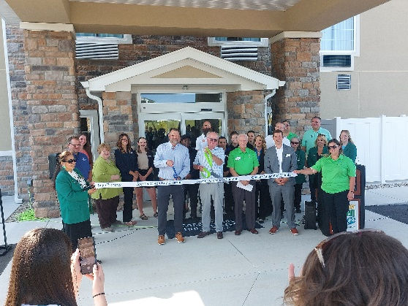**Cobblestone Hotels, LLC celebrates the grand opening of the Cobblestone Hotel & Suites in Denmark, Wisconsin.**   
  
September 12, 2024 – Neenah, WI – Cobblestone Hotels celebrated the grand opening and official ribbon cutting ceremony for their new hotel in Denmark, Wisconsin.  
  
Members of the community gathered alongside key players who brought this project to fruition to celebrate the addition of this hotel to the village of Denmark. In attendance were representatives from the [Village of Denmark](https://www.denmark-wi.org/), [Discover Green Bay](https://www.greenbay.com/), [JCW Development](https://jcwdev.net/), [WDS Construction](https://wdsconstruction.net/), and members of the Cobblestone Hotels corporate team.

Susan Sellner, Denmark Village President, took a moment to share her vision for the future of the hotel in the community, stating that “Cobblestone is giving us a chance to show visitors our area and village”. Denmark is central to many key area businesses, event venues, and recreational opportunities. The village is just a short drive from the major city of Green Bay, which hosts a multitude of large events throughout the year.

Brad Toll, President and CEO of Discover Green Bay, expressed a similar sentiment about the future of the village when he said “You’ve got a fantastic tourism community here in Denmark”, noting that the hotel will provide an attractive lodging option for visitors coming to the area for the upcoming 2025 NFL draft, local sports events, and events held at the newly constructed Expo Hall in nearby Green Bay.

Jeremy Griesbach, President of Development with Cobblestone Hotels, shared his excitement about the partnership between Cobblestone Hotels and the village of Denmark when he said “It is very exciting to see communities like Denmark grow and prosper”. Griesbach stated “Like everybody says, I think the Cobblestone hotel here will really be a big piece of that, to keep more people here and supporting more of that local business”.   
  
This 54-guestroom hotel boasts the consistent amenities of the Cobblestone Brand, including high-speed internet access, a complimentary hot breakfast each morning, and 24-hour Seattle’s Best Coffee service for all guests to enjoy. Guestrooms are perfectly tailored to meet the needs of the modern traveler, while designed with an element of contemporary elegance. In-room amenities include flat-screen TVs, microwaves, mini-refrigerators, in-room coffee brewers, hairdryers, iron and ironing boards, sturdy desks, luxury linens, and bathroom essentials.  
  
The Cobblestone Hotel & Suites hosts an onsite exercise facility, indoor pool, 24-hour Cobblestone Marketplace convenience store, complimentary onsite parking, and a business center. This Cobblestone location also features a meeting room that is available to rent for social and corporate events.   
  
Whether you are travelling for business or leisure, when you stay Cobblestone, you will experience the “Big City Quality.... Small Town Values” that each location has to offer. Visit [www.staycobblestone.com](http://www.staycobblestone.com) for reservations and more.   
  
To stay up to date with all of Cobblestone’s current and upcoming projects, please “like” Cobblestone Hotels on Facebook: <https://www.facebook.com/cobblestonehotels/.>

**About Cobblestone Hotels**

Based in Neenah, WI Cobblestone Hotels, LLC is a leading upper-midscale hotel brand with over 165 hotels open, under construction, or in development in 28 states. The company continues to pride itself in filling the lodging needs of communities through its upper mid-scale new build brand. Signature amenities include high-speed Internet access, complimentary breakfast, convenience store, fitness centers, business centers, and more.

Cobblestone Hotels includes Cobblestone Hotels & Suites, Cobblestone Inn & Suites, Riverstone Suites, Boarders Inn & Suites, Centerstone Hotels, and KeyWest Hotels. For development information please visit [www.CobblestoneFranchising.com.](http://www.cobblestonefranchising.com/)

Cobblestone Hotels offers the Cobblestone Rewards frequent stayer program where guests receive ten points for every dollar spent, and can be redeemed as award nights, or with other redemption partners. For more information visit [www.CobblestoneRewards.com](http://www.cobblestonerewards.com/)

Contact: [marketing@staycobblestone.com](mailto:marketing@staycobblestone.com)