NEWS RELEASE
COBBLESTONE HOTELS, LLC OPENS WINTERS, TEXAS
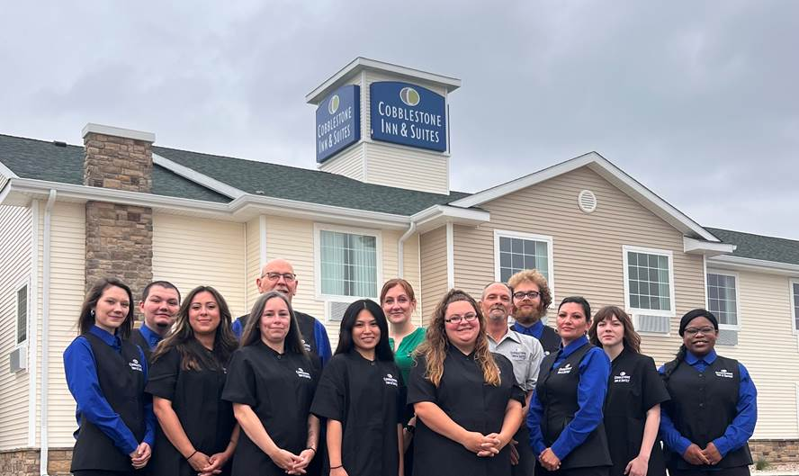
May 9, 2024 – Neenah, WI – Cobblestone Hotels announces the opening of the Cobblestone Inn & Suites in Winters, Texas. This 35-guestroom hotel is located at 800 South Main Street in the city of Winters, at the intersection of TX-153 and US Highway 83. The metropolitan city of Abilene, Texas is 40 miles north of Winters, and can be reached in under an hour by way of US-83.
The Cobblestone Inn & Suites - Winters provides easy access to several local businesses and attractions. North Runnels Hospital is less than a mile from the hotel, and other local businesses such as Apple Moving, Winters Truck and Trailer Repair, Lund International are located within easy driving distance. The Crossing Travel Market is a popular stop with truck drivers and travelers and is located directly across the street from the Cobblestone Inn & Suites.
Unique local eats include Rangel's Family Restaurant, Casa Cabana, and Buddy’s Grill. The nearby ZI Hale museum offers an in-depth look at what life was like for early Runnells County residents and showcases a variety of collections and exhibitions to browse. Elm Creek Reservoir is 10 miles east of Winters and is a popular local spot for fishing, swimming, and camping.
The Cobblestone Inn & Suites – Winters offers guests classic Cobblestone amenities like coffee and tea makers, mini-refrigerators, microwaves, and flat-screen televisions in every room. A complimentary hot breakfast is offered each morning, and high-speed internet access can be found throughout the hotel. Complimentary Seattle’s Best coffee is featured 24/7 in the lobby as well as in each guestroom. Onsite services such as coin-operated guest laundry, a business center with a computer and printer, and an onsite exercise facility are available for all who choose to Stay Cobblestone while visiting Winters.
Whether you are travelling for business or leisure, when you stay Cobblestone, you will experience the “Big City Quality.... Small Town Values” that each location has to offer. Visit www.staycobblestone.com for reservations and more.
Follow us on Facebook to stay up to date on all our new and upcoming locations at https://www.facebook.com/cobblestonehotels/
About Cobblestone Hotels
Based in Neenah, WI Cobblestone Hotels, LLC is a leading upper-midscale hotel brand with over 175 hotels open, under construction, or in development in 29 states. The company continues to pride itself in filling the lodging needs of communities through its upper mid-scale new build brand. Signature amenities include high-speed Internet access, complimentary breakfast, convenience store, fitness centers, business centers, and more.

Cobblestone Hotels includes Cobblestone Hotels & Suites, Cobblestone Inn & Suites, Riverstone Suites, Boarders Inn & Suites, Centerstone Hotels, and KeyWest Hotels. For development information please visit www.CobblestoneFranchising.com.
Cobblestone Hotels offers the Cobblestone Rewards frequent stayer program where guests receive ten points for every dollar spent, and can be redeemed as award nights, or with other redemption partners. For more information visit www.CobblestoneRewards.com
Contact: marketing@staycobblestone.com

