NEWS RELEASE
COBBLESTONE HOTELS, LLC SIGNS EATON, OHIO
February 22, 2024 – Neenah, WI – Cobblestone Hotels announces their continued growth in the state of Ohio with the signing of the coming soon Cobblestone Hotel & Suites in Eaton, OH with Eaton Hospitality Group, LLC.
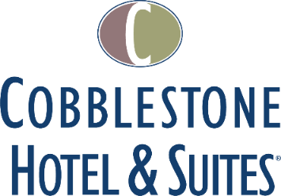
This Cobblestone Hotel & Suites location will host 66 tastefully designed, modern guestrooms dispersed across three floors. The hotel will feature the Cobblestone Marketplace-branded onsite convenience store, a meeting room, indoor pool, business center, and an elevator to allow easy access to all levels of the facility. This location will also offer a hot complimentary breakfast served each day, Seattle’s Best coffee service, and high-speed internet access throughout the hotel.
Guestrooms are designed with an element of contemporary elegance and are perfectly tailored to meet the needs of modern travelers. In-room amenities include flat-screen TVs, additional recharge outlets for electronics, microwaves, mini-refrigerators, in-room coffee brewers, hairdryers, iron and ironing boards, desks, luxury linens, and bathroom essentials.
For updates on the progress of this location and others, please “like” Cobblestone Hotels on Facebook: https://www.facebook.com/cobblestonehotels/
Whether you are traveling for business or for leisure, you will experience the “Big City Quality... Small Town Values” that each location has to offer. Visit www.CobblestoneHotels.com for reservations or for more information.
About Cobblestone Hotels
Based in Neenah, WI Cobblestone Hotels, LLC is a leading upper-midscale hotel brand with over 175 hotels open, under construction, or in development in 29 states. The company continues to pride itself in filling the lodging needs of communities through its upper mid-scale new build brand. Signature amenities include high-speed Internet access, complimentary breakfast, onsite convenience stores, onsite fitness centers, onsite business centers, and more.
Cobblestone Hotels includes Cobblestone Hotels & Suites, Cobblestone Inn & Suites, Riverstone Suites, Boarders Inn & Suites, Centerstone Hotels, and KeyWest Hotels. For development information please visit www.CobblestoneFranchising.com.
Cobblestone Hotels offers the Cobblestone Rewards frequent stayer program where guests receive ten points for every dollar spent, and can be redeemed as award nights, or with other redemption partners. For more information visit www.CobblestoneRewards.com.
Contact: marketing@staycobblestone.com

