NEWS RELEASE
COBBLESTONE HOTELS, LLC OPENS CULLMAN, ALABAMA
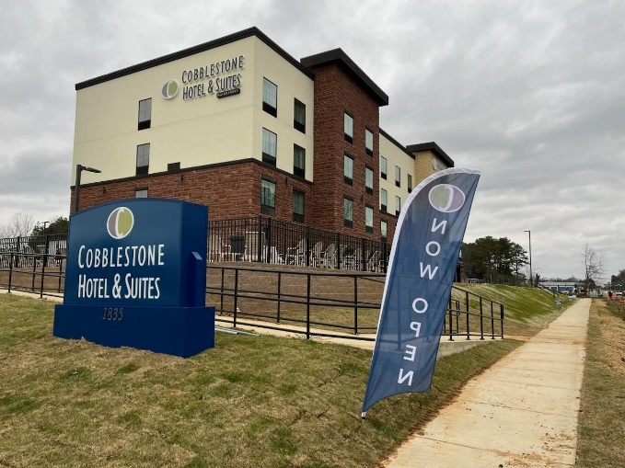
December 29, 2023 – Neenah, WI – Cobblestone Hotels announces the opening of the Cobblestone Hotel & Suites in Cullman, Alabama. This 63-guestroom hotel is located at 1835 Main Avenue SW in the city of Cullman, just off Interstate 65.
Visitors to Cullman will find endless opportunities to explore the city when they stay at the Cobblestone Hotel & Suites. Cullman offers the variety and excitement of a larger city while still maintaining its rural roots, offering a range of activities that means fun for everyone! Visitors will not want to miss the chance to tour the historic miniature buildings at Ave Maria Grotto, which is a short four miles from the hotel. Sportsman Lake is a popular local destination with fishermen and water sports enthusiasts. Other activities in the area include antique shopping, hiking and bicycle trails, bowling, and much more!
Those travelling for business will appreciate this hotel’s proximity to several major local businesses, such as the Walmart Distribution Center and Cullman Electric Cooperative. Cullman Industrial Park II is located less than two miles from the Cobblestone Hotel & Suites and is a major business hub in the area. Also nearby are several event venues such as Loft 212, Cullman County Agricultural, and Brick Haven Venue. The Rock the South festival grounds are just a five minute drive from the hotel.
The Cobblestone Hotel & Suites - Cullman offers guests classic Cobblestone amenities like coffee and tea makers, mini-refrigerators, microwaves, and flat-screen televisions in every room. A complimentary hot breakfast is offered each morning, and high-speed internet access can be found throughout the hotel. Onsite services such as coin-operated guest laundry, a business center with a computer and printer, an outdoor swimming pool, and an onsite exercise facility are available for all who choose to Stay Cobblestone while visiting Cullman. Guests will also be able to enjoy an unforgettable meal at the hotel’s onsite restaurant, the Wissota Chophouse, which will be opening soon on the ground floor of the Cobblestone Hotel & Suites.
Whether you’re travelling for business or leisure, you will experience the “Big City Quality… Small Town Values” that each location has to offer. Visit www.CobblestoneHotels.com for reservations and additional information.
Follow us on Facebook to stay up to date on all of our new and upcoming locations at https://www.facebook.com/cobblestonehotels/
About Cobblestone Hotels
Based in Neenah, WI Cobblestone Hotels, LLC is a leading upper-midscale hotel brand with over 172 hotels open, under construction, or in development in 29 states. The company continues to pride itself in filling the lodging needs of communities through its upper mid-scale new build brand. Signature amenities include high-speed Internet access, complimentary breakfast, an onsite convenience store, fitness centers, business centers, and more.

Cobblestone Hotels includes Cobblestone Hotels & Suites, Cobblestone Inn & Suites, Cobblestone Hotel & Suites Main Street, Cobblestone Inn & Suites Main Street, Boarders Inn & Suites, Centerstone Hotels, Riverstone Suites, and KeyWest Hotels. For development information please visit www.CobblestoneFranchising.com.

Cobblestone Hotels offers the Cobblestone Rewards frequent stayer program where guests receive ten points for every dollar spent, and can be redeemed as award nights, or with other redemption partners. For more information visit www.CobblestoneRewards.com
Contact: marketing@staycobblestone.com

