NEWS RELEASE
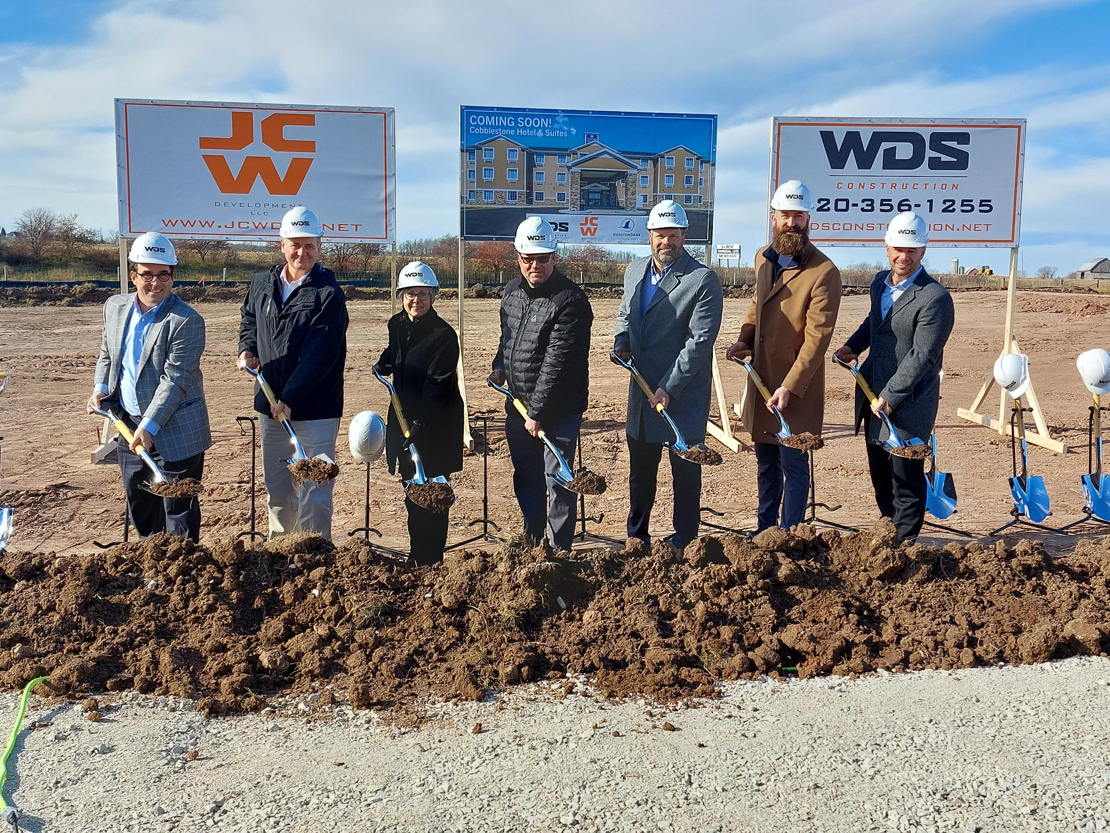
COBBLESTONE HOTELS, LLC BREAKS GROUND IN DENMARK, WISCONSIN
November 17, 2023 – Neenah, WI – Cobblestone Hotels celebrated the groundbreaking of their new hotel that is coming soon to Denmark, Wisconsin.
In attendance were representatives from JCW Development and WDS Construction, Horicon Bank, representatives from the village of Denmark, and members of the Cobblestone Hotels team. All gathered in a demonstration of partnership and of support for this exciting new addition to the community of Denmark.
Matt Krogman, Development Manager at JCW Development, described his experience with the journey of establishing the Cobblestone Hotel & Suites in Denmark. “I want to really emphasize the difficulties” Krogman said, “because that lends itself to the wonderful partnerships that we’ve had, and without those partnerships we wouldn’t have been able to get to this point”. Krogman thanked all parties involved in bringing this project to fruition, who demonstrated perseverance and passion in overcoming any challenges along the way.
The village of Denmark played a vital role in identifying the need for a hotel and working with the parties involved to get the project off the ground. Village President Susan Selner shared her enthusiasm for the commencement of construction for the Cobblestone Hotel & Suites, stating that “Today is the culmination of two years spent bringing one of Denmark’s primary goals forward”. Selner shared that it has been an ongoing focus of the village board to bring a quality lodging solution to the community, to provide opportunities for growth in Denmark and support the financial goals of the village.
Jeremy Griesbach, President of Development with Cobblestone Hotels, shared his enthusiasm for the growth of the brand in Wisconsin, where thirty of Cobblestone’s one hundred and seventy-four locations are located, with four of those being under construction. Cobblestone Hotels is currently the only hotel franchise company based out of the state, and Griesbach expressed his enthusiasm for working with local entities such as JCW Development and WDS construction, stating that “It’s a great partnership with Wisconsin companies, and that’s exciting for us”.
This hotel will be a fifty-four-room facility spanning three stories. Guests will be able to enjoy Cobblestone’s consistent amenities, such as 24-hour Seattle’s Best Coffee service, high-speed internet access, and a complimentary hot breakfast each morning. Guestrooms will be equipped with flat-panel televisions, microwaves, refrigerators, and in-room personal coffee brewers.
The Cobblestone Hotel & Suites will be located on Bohemia Drive in Denmark, Wisconsin. This hotel will host an indoor pool, business center, onsite fitness center, and onsite convenience store to meet the needs of those seeking lodging in the Denmark area. The property is being constructed by WDS Construction and managed by Slate Hospitality Group.
For updates on the progress of this location and others, please “like” Cobblestone Hotels on Facebook: https://www.facebook.com/cobblestonehotels/.
About Cobblestone Hotels
Based in Neenah, WI Cobblestone Hotels, LLC is a leading upper-midscale hotel brand with over 172 hotels open, under construction, or in development in 29 states. The company continues to pride itself in filling the lodging needs of communities through its upper mid-scale new build brand. Signature amenities include high-speed Internet access, complimentary breakfast, convenience store, fitness centers, business centers, and more.

Cobblestone Hotels includes Cobblestone Hotels & Suites, Cobblestone Inn & Suites, Boarders Inn & Suites, Centerstone Hotels, and KeyWest Hotels. For development information please visit www.CobblestoneFranchising.com.

Cobblestone Hotels offers the Cobblestone Rewards frequent stayer program where guests receive ten points for every dollar spent, and can be redeemed as award nights, or with other redemption partners. For more information visit www.CobblestoneRewards.com
Contact: marketing@staycobblestone.com

