NEWS RELEASE
COBBLESTONE HOTELS, LLC SIGNS DENMARK, WISCONSIN
December 4, 2023 – Neenah, WI – Cobblestone Hotels announces their continued growth in the state of Wisconsin with the signing of the coming soon Cobblestone Hotel & Suites in Denmark, WI with JCW CBSTN Denmark, LLC.
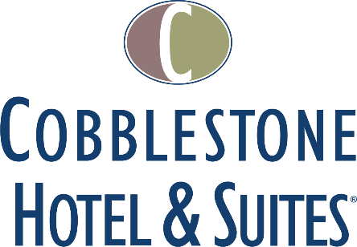
This Cobblestone Hotel & Suites location will host 54 tastefully designed, modern guestrooms dispersed across three floors. The hotel will feature the Cobblestone Marketplace-branded onsite convenience store, a meeting room, indoor pool, onsite lounge, business center, and an elevator to allow easy access to all levels of the facility. This location will also offer a hot complimentary breakfast served each day, Seattle’s Best coffee service, and high-speed internet access throughout the hotel.
Guestrooms are designed with an element of contemporary elegance and are perfectly tailored to meet the needs of modern travelers. In-room amenities include flat-screen TVs, additional recharge outlets for electronics, microwaves, mini-refrigerators, personal coffee and tea brewers, hairdryers, iron and ironing boards, desks, luxury linens, and bathroom essentials.
For updates on the progress of this location and others, please “like” Cobblestone Hotels on Facebook: https://www.facebook.com/cobblestonehotels/
Whether you are traveling for business or for leisure, when you stay Cobblestone you will experience the “Big City Quality... Small Town Values” that each location has to offer. Visit www.CobblestoneHotels.com for reservations or for more information.
About Cobblestone Hotels
Based in Neenah, WI Cobblestone Hotels, LLC is a leading upper-midscale hotel brand with over 172 hotels open, under construction, or in development in 29 states. The company continues to pride itself in filling the lodging needs of communities through its upper mid-scale new build brand. Signature amenities include high-speed Internet access, complimentary breakfast, an onsite convenience store, fitness centers, business centers, and more.

Cobblestone Hotels includes Cobblestone Hotels & Suites, Cobblestone Inn & Suites, Cobblestone Hotel & Suites Main Street, Cobblestone Inn & Suites Main Street, Boarders Inn & Suites, Centerstone Hotels, Riverstone Suites and KeyWest Hotels. For development information please visit www.CobblestoneFranchising.com.

Cobblestone Hotels offers the Cobblestone Rewards frequent stayer program where guests receive ten points for every dollar spent, and can be redeemed as award nights, or with other redemption partners. For more information visit www.CobblestoneRewards.com
Contact: marketing@staycobblestone.com

