NEWS RELEASE
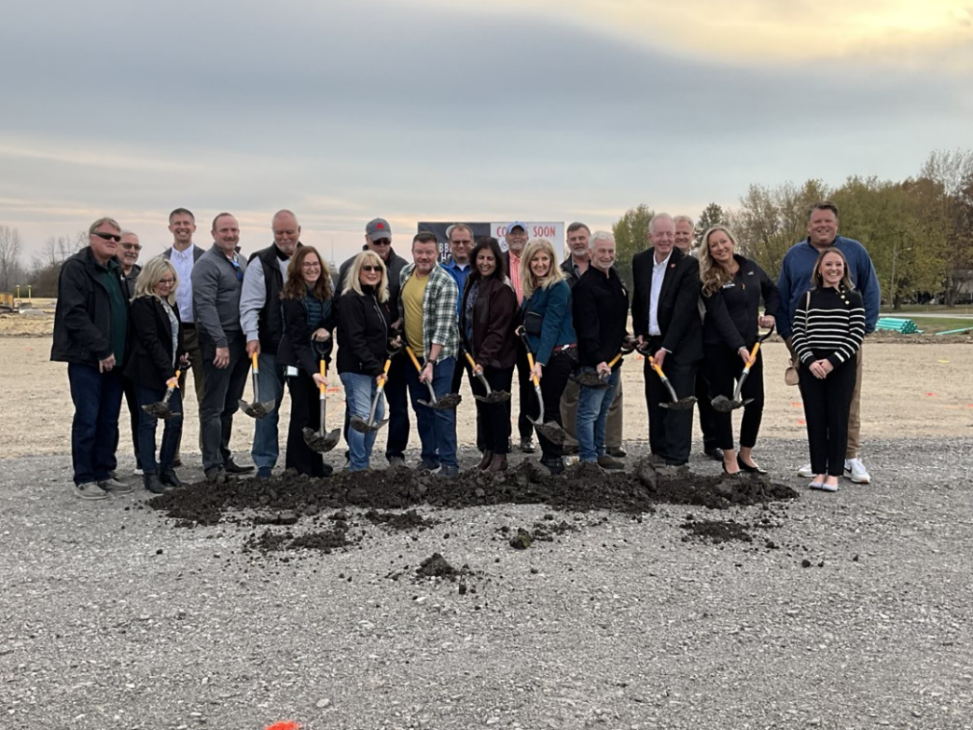
COBBLESTONE HOTELS, LLC BREAKS GROUND IN RUSSELLS POINT AT INDIAN LAKE, OH
November 6, 2023 – Neenah, WI – Cobblestone Hotels celebrated the groundbreaking of their new hotel that is coming soon to Russells Point at Indian Lake, Ohio.
Members of the village of Russells Point gathered to welcome Cobblestone to the community. Among the crowd were representatives from the Logan County Commissioner’s office, members of the Indian Lake Chamber of Commerce, representatives of Richwood Bank, and members of the Cobblestone Hotels team. The community gathered at the site of the future Cobblestone Hotel & Suites to celebrate the journey of bringing this hotel to the community and the many benefits that this construction represents for the future of Russells Point at Indian Lake.
Mike Majors, representing the investment group behind the Cobblestone Hotel & Suites – Russells Point at Indian Lake, shared insight into the history of the partnership between Cobblestone and the village, which began with another Cobblestone location, the Cobblestone Hotel & Suites – Urbana, years earlier. Recalling his experience with Cobblestone in Urbana, Majors said that “I got excited, because for years I was looking for a franchise that would come into a small community, and really be able to serve a small community with a quality hotel, and it’s hard to find”. After reflecting on his experience with Cobblestone on this past project, Majors stated “I just wanted to say that this hotel will lift this community up”, continuing to speak of the benefits that the addition of this hotel is expected to bring to the community of Russells Point, including bringing job opportunities to the area and supporting the local economy.
Ben Volrath, President of the Logan County Chamber of Commerce, took an opportunity to thank the people of Russells Point and expand on the support that this project received from the entire community. “This is one of those projects that doesn’t just happen, it’s been years in the making, and you all are the ones to thank” Volrath said, addressing the crowd. The hotel’s construction is an incredible start in the journey of transforming a community through hospitality, but Volrath reminded the crowd that there is still much work to be done. “This is just the beginning” Volrath said, before encouraging those in attendance to spread the word about the new hotel and encourage travelling friends, family, and business associates to stay in Russells Point, and to stay in Logan County.
Jeremy Griesbach, President of Development with Cobblestone Hotels, thanked all of those who played a part in bringing Cobblestone to Russells Point at Indian Lake. “The local participation is what gets these projects done” Griesbach said, highlighting the passion that the investors and local official parties have for their community. The addition of the Cobblestone Hotel & Suites marks the fourth hotel in the state of Ohio that is currently open or under construction with Cobblestone Hotels. The growth of the brand is a testament to the spirit and upward growth of small-town America, which is the market that the Cobblestone brand has dedicated itself to from its inception in 2007.
This hotel will be a fifty-four-room facility spanning three stories. Guests will be able to enjoy Cobblestone’s consistent amenities, such as 24-hour Seattle’s Best Coffee service, high-speed internet access, and a complimentary hot breakfast each morning. Guestrooms will be equipped with flat-panel televisions, microwaves, refrigerators, and in-room personal coffee brewers.
The Cobblestone Hotel & Suites will be located at 448 East Main Street in Russells Point, Ohio. This hotel will host an indoor pool, business center, onsite fitness center, and onsite convenience store to meet the needs of those seeking lodging in the Indian Lake area. The property is being constructed by BriMark Builders and managed by Slate Hospitality Group.
For updates on the progress of this location and others, please “like” Cobblestone Hotels on Facebook: https://www.facebook.com/cobblestonehotels/.
About Cobblestone Hotels
Based in Neenah, WI Cobblestone Hotels, LLC is a leading upper-midscale hotel brand with over 172 hotels open, under construction, or in development in 29 states. The company continues to pride itself in filling the lodging needs of communities through its upper mid-scale new build brand. Signature amenities include high-speed Internet access, complimentary breakfast, convenience store, fitness centers, business centers, and more.

Cobblestone Hotels includes Cobblestone Hotels & Suites, Cobblestone Inn & Suites, Boarders Inn & Suites, Centerstone Hotels, and KeyWest Hotels. For development information please visit www.CobblestoneFranchising.com.

Cobblestone Hotels offers the Cobblestone Rewards frequent stayer program where guests receive ten points for every dollar spent, and can be redeemed as award nights, or with other redemption partners. For more information visit www.CobblestoneRewards.com
Contact: marketing@staycobblestone.com

