NEWS RELEASE
COBBLESTONE HOTELS, LLC CELEBRATED THEIR ANNUAL BRAND CONFERENCE IN LAS VEGAS, NEVADA.
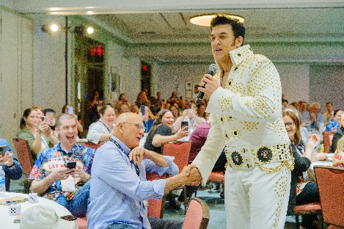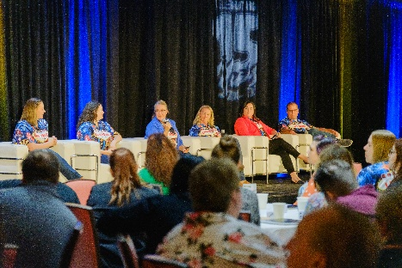
NEENAH, WISCONSIN – The Cobblestone community gathered in Las Vegas, Nevada on September 27th and 28th to celebrate their fifteen-year brand anniversary and reflect on the journey to today. There was a focus on revisiting the standards and values that make the Cobblestone hotel chain unique and discussing tools to give the brand a new energy going into 2024. Major topics of discussion included team development, elevating customer care, and approaching sales with a new perspective.
STRENGTHENING THE TEAMS AT OUR PROPERTIES
Owners, operators, general managers, and sponsors joined the Cobblestone team in Las Vegas for two days of learning and networking. The annual partner showcase provided an opportunity for sponsors to interact face to face with decision makers at the properties, allowing for questions and demonstrations on exciting programs and systems that could be utilized by the hotels to drive revenue and elevate guest experience.
Speakers and panelists shared a focus on developing the front-line employees at the hotels and thinking creatively about ways to approach sales. The first breakout session featured a panel of experienced owners and operators who shared their perspectives on employee retention from the standpoint of hotel management in the aptly titled “Don’t Gamble on Your Employees” session. They discussed the strategies that they have seen work at their properties, as well as shared personal stories of their experiences with managing employees throughout their careers. They offered ways to encourage team bonding as well as suggestions on how to handle the difficult situations that often arise when working closely with others.
This year’s keynote speaker was the esteemed Meridith Elliott Powell, who is an accomplished author, speaker, and business strategist. Powell shared compelling stories of how businesses had overcome major challenges and adapted their sales techniques to adjust to the changing times throughout history. Powell’s entertaining and compelling presentations served to inspire general managers to look at the importance of sales through new eyes.
REVISITING OUR CORE VALUES: A REFRESH ON BRAND DIRECTIVES AND PROGRAMS
Cobblestone’s brand services team works throughout the year to monitor the performance of brand directives, coach properties on how to implement brand standards, and perform quality assurance checks to ensure that properties are aligned with the goals and values of the Cobblestone brand. The corporate brand services team presented brand updates to look forward to in late 2023 into 2024, including a new bulk amenities program and the goal to release additional educational materials to make learning easier while on property.
The brand services team shared promising news about the Cobblestone Rewards Program, including seeing an increase across all KPI for the second year in a row. Notably, there was a 34% increase in member sign-ups and an overall revenue increase of 40% from last year. Much of this year’s success is attributed to the quarterly promotions that have been implemented, and which the brand plans to continue exploring and improving on in the coming years.
This year saw a full return of the Quality Assurance Inspection, which had been temporarily suspended in 2022 in consideration of the challenges presented by the pandemic. Jackie Klehr and Sherry Noska, Regional Directors of Brand Services, gave an overview of the inspection as well as what to expect when they visit your property before going into some of the trends that they noticed while onsite. They urged that special attention should be paid to critical items such as the Reputation Portal, Rewards Program, Coffee Program, and Uniform Program.
Klehr and Noska also touched on the topic of guest satisfaction, specifically in the area of guest complaints. They discussed the process that must be followed when a complaint is received by the property, and held a session on Thursday where they dove deeply into the importance of handling guest complaints swiftly and effectively as well as best practices.
The Cobblestone Reputation portal was another large subject of conversation, particularly the survey function, which sends a simple survey to guests encouraging them to select if they were satisfied or dissatisfied with their stay, and then redirects them to leave a public comment if they were satisfied or sends their message directly to the hotel if they were dissatisfied. Brand President Josie Kilgore shared statistics from 2023, including a 9.7% increase in positive experiences being sent to TripAdvisor and Google and a 10% overall decrease in public negative reviews from 2022. Kilgore encouraged properties to continue utilizing this tool as a way to improve hotel visibility and satisfaction scores.
MANAGING THE GROWTH OF THE BRAND: CELEBRATING FUTURE PROJECTS AND MAINTAINING ROOTS
Jeremy Griesbach, President of Development for Cobblestone Hotels, shared exciting updates from the development front as a result of the hard work of his team. Last year saw the addition of seven new hotel openings to the Cobblestone Brand, representing the growth of Cobblestone in the states of Wisconsin, Colorado, and Iowa. There have been seven new signings since the 2022 conference, which will see the Cobblestone Brand expanding in the states of Oklahoma, Ohio, Utah, Missouri, Alabama, Wisconsin, and Colorado.
Griesbach announced that as of September 2023, there were fifteen locations that are either currently under construction or are soon to break ground, with countless more in the works on the part of the development team. Three of these locations are projected to open within the coming year in brand new states for Cobblestone, which include Cullman Alabama, Wickenburg Arizona, and Lynden Washington. These hotels will also host the Wissota Chophouse, marking the expansion of the Wissota Chophouse brand into these three new states as well.
Griesbach, alongside Brand President Josie Kilgore, formally introduced Cobblestone’s fist extended stay brand, Riverstone Suites, which has broken ground in Chippewa Falls, Wisconsin. Griesbach described the brand as “An upper midscale approach to the traditional hotel experience, with a focus on efficiency and convenience for guests that find themselves away from home for longer than the standard stay”. Features of this hotel are to include expanded laundry facilities, an expanded self-serve marketplace, an onsite bar, and digital check in. This property will consist of 58 suites with expanded living space, and kitchens that feature 4-burner stoves, full sized refrigerators, dishwashers, and microwaves.
Though the Cobblestone Brand is excited to continue the current path of growth, Griesbach reminded the attendees that the focus of Cobblestone will remain on small town America. Griesbach assured the group that the pipeline for next year looks promising and shared his hopes of continuing to expand the Cobblstone footprint in the Midwest, as well as pushing growth in the Southern part of the United States as well.
2022 BRAND AWARDS
The two days of events ended with the annual Cobblestone Brand Awards Ceremony, where attendees gathered to recognize the properties and individuals who performed exceptionally throughout the previous year. This year’s award recipients were strong in the areas of brand standards, guest satisfaction, and employee satisfaction. Nominations as well as performance in brand KPIs determined the nominees of this year’s awards. Winners of the 2022 Cobblestone Brand Awards include:
Investor of the Year: Sara McKay, Cobblestone Hotel & Suites - Knoxville
General Manager of the Year: Hunter Santiago – Cobblestone Inn & Suites - Kersey
Employee of the Year: Jeff Paulson, Cobblestone Hotel & Suites – Stevens Point
Property of the Year: Cobblestone Inn & Suites - Yuma
These award recipients will be honored with plaques to be placed on display at their properties, so if your travels take you to any of these cities be sure to stop by and say congratulations! These individuals truly embody the values of the Cobblestone Brand, and are true examples to the larger Cobblestone community.
About Cobblestone Hotels
Based in Neenah, WI Cobblestone Hotels, LLC is a leading upper-midscale hotel brand with over 170 hotels open, under construction, or in development in 29 states. The company continues to pride itself in filling the lodging needs of communities through its upper mid-scale new build brand. Signature amenities include high-speed Internet access, complimentary breakfast, convenience store, fitness centers, business centers, and more.

Cobblestone Hotels includes Cobblestone Hotels & Suites, Cobblestone Inn & Suites, Boarders Inn & Suites, Riverstone Suites, Centerstone Hotels, and KeyWest Hotels. For development information please visit www.CobblestoneFranchising.com.

Cobblestone Hotels offers the Cobblestone Rewards frequent stayer program where guests receive ten points for every dollar spent, and can be redeemed as award nights, or with other redemption partners. For more information visit www.CobblestoneRewards.com

Contact: marketing@staycobblestone.com

