**NEWS RELEASE**

**COBBLESTONE HOTELS, LLC CELEBRATES THE GRAND OPENING OF THE COBBLESTONE INN & SUITES IN SHELDON, IOWA**

August 4, 2023 – Neenah, WI – Cobblestone Hotels celebrated the grand opening and official ribbon cutting ceremony for their new location in Iowa. Laurie Woolslayer, Vice President of Sales and Operations for Diamond Hospitality Services, opened the ceremony with a heartfelt thank you to all of those who helped make the Cobblestone Inn & Suites – Sheldon possible. In attendance were representatives of the [Sheldon Chamber & Development Corporation](https://sheldoniowa.com/chamberofcommerce/), representatives of the City of Sheldon, representatives from the hotel’s management company [Diamond Hospitality Services, LLC](https://www.diamondhospitalityllc.com/), and members of the Cobblestone Hotels team.   
  
Trevor Gottula with the Sheldon Chamber of Commerce shared his enthusiasm for the new hotel, describing the benefit that this hotel will bring to the city in partnership with the [Crossroads Pavillion,](https://crossroadspavilion.com/) which is an impressive local event space. “This is going to be a place that people are going to come and stay.” said Gottula, noting that the Cobblestone Inn & Suites is within a short walking distance of the Pavilion.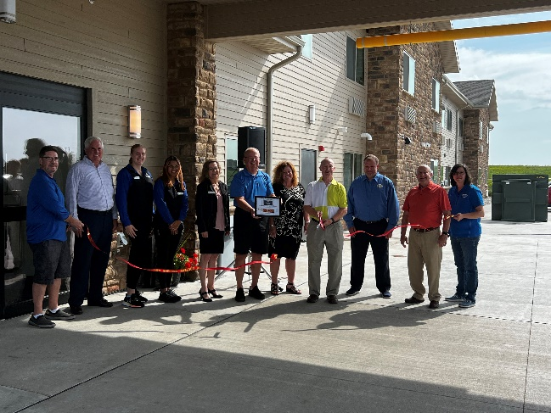

Cobblestone Hotels is enthusiastic about the franchise’s continued growth in the state of Iowa that the grand opening of the Cobblestone Inn & Suites - Sheldon represents. Jeremy Griesbach, President of Development for Cobblestone Hotels, shared that “Iowa is our second largest state”, proceeding to note that “we are now at 28 open or under construction with the Cobblestone Brand here in Iowa”. Cobblestone’s development team focuses on bringing quality lodging to smaller markets, evolving and growing alongside the community in the process. The Cobblestone Inn & Suites is expected to be a dynamic local partner for the many events and local businesses that bring visitors to the city, including attractions like the Christian Music Festival RiseFest and the Crossroads Pavilion.

Tom Kennedy, President of Diamond Hospitality Services, closed out the speaking portion of the ceremony by expressing his appreciation for the Cobblestone Brand and for the community of Sheldon. Kennedy shared that he had spent time in the past week visiting several Cobblestone locations and spoke on his impressions of the brand, which he termed the “Three P’s” - People, Pride, and Patience. Kennedy called out the cooperation and dedication that he observed throughout the process of bringing the Sheldon hotel to where it stands today, including the teamwork between the investors, the hotel’s opening team, and Cobblestone Hotels. “One of the things we’ve learned throughout this is, on a daily basis, we have to make sure that all of us remain proud” Kennedy said. “We are proud to be a part of it, we appreciate the opportunity to be here today, and congratulations to everyone, this is your hotel”.

The Cobblestone Inn & Suites is located at 271 34th Avenue in the City of Sheldon, right off of IA-60. Visitors may find themselves in Sheldon while attending an event at the Crossroads Pavilion Event Center or while visiting the Northwest Iowa Community College.   
This 40-guestroom hotel boasts the consistent amenities of the Cobblestone Brand, including high-speed internet access, a complimentary hot breakfast each morning, and 24-hour Seattle's Best Coffee service for all guests to enjoy. Guestrooms are perfectly tailored to meet the needs of the modern traveler, while designed with an element of contemporary elegance. In-room amenities include flat-screen TVs, additional recharge outlets for electronics, microwaves, mini-refrigerators, in-room coffee brewers, hairdryers, iron and ironing boards, sturdy desks, luxury linens, and bathroom essentials.

The Cobblestone Inn & Suites hosts an onsite exercise facility, onsite lounge, and a business center. This location also has a Cobblestone Marketplace convenience store and guest laundry services for the convenience of all guests.   
  
Whether you are travelling for business or leisure, when you stay Cobblestone you will experience the big city quality and small-town values that each location has to offer. Visit [www.staycobblestone.com](http://www.staycobblestone.com) for reservations and more.

For updates on the progress of this location and others, please “like” Cobblestone Hotels on Facebook: [https://www.facebook.com/cobblestonehotels/.](https://www.facebook.com/cobblestonehotels/)

**About Cobblestone Hotels**

Based in Neenah, WI Cobblestone Hotels, LLC is a leading upper-midscale hotel brand with over 168 hotels open, under construction, or in development in 29 states. The company continues to pride itself in filling the lodging needs of communities through its upper mid-scale new build brand. Signature amenities include high-speed Internet access, complimentary breakfast, convenience store, fitness centers, business centers, and more.

Cobblestone Hotels includes Cobblestone Hotels & Suites, Cobblestone Inn & Suites, Boarders Inn & Suites, Centerstone Hotels, and KeyWest Hotels. For development information please visit [www.CobblestoneFranchising.com.](http://www.cobblestonefranchising.com/)

Cobblestone Hotels offers the Cobblestone Rewards frequent stayer program where guests receive ten points for every dollar spent, and can be redeemed as award nights, or with other redemption partners. For more information visit [www.CobblestoneRewards.com](http://www.cobblestonerewards.com/)

Contact: [marketing@staycobblestone.com](mailto:marketing@staycobblestone.com)