NEWS RELEASE
COBBLESTONE HOTELS, LLC CELEBRATES THE GRAND OPENING OF THE COBBLESTONE HOTEL & SUITES IN MOSINEE, WI
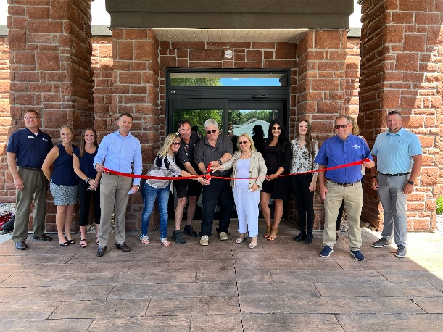
August 10, 2023 – Neenah, WI – Cobblestone Hotels celebrated the grand opening and official ribbon cutting ceremony for their new location in Mosinee, Wisconsin.
In attendance were representatives from the City of Mosinee, members of the investment group, Mosinee Area Chamber of Commerce members, members of the Wisconsin Economic Development Corporation, and representatives from Cobblestone Hotels.
Mayor of the City of Mosinee, Brent Jacobson, welcomed the addition of the hotel to the community of Mosinee, and spoke on the benefit that it is expected to bring to the city in partnership with other community assets such as the Central WI Business Park and the Central Wisconsin Airport. “To get to this point, with any of these projects, it’s been a tremendous public, private partnership” said Jacobson, as he thanked the parties that invested their time and money in this project that would ultimately serve the city of Mosinee and its inhabitants.
Multiple groups who are passionate about the economic development of the city were present, including CEO of the Wisconsin Economic Development Corporation, Missy Hughes. “It’s incredibly important to have this kind of facility here” said Hughes “to help catalyze those other pieces of economic activity, and that’s one of the reasons that we’re really pleased to be able to step in and help you do this here today”. State Senator Cory Tomczyk also shared his support for the hotel and for Mosinee when he stated that “This is a community investment, it’s going to help everyone, it makes our economy stronger”.
Jacquelyn Forbes-Kearns spoke on behalf of the investment group of the hotel, the Mosinee Hotel Group, LLC. “We strongly believe that this project will be a catalyst for further development in Mosinee and the greater Mosinee area” said Kearns, thanking the entities and individuals who believe in Mosinee and helped push the project forward.
Jeremy Griesbach, President of Development for Cobblestone Hotels, shared his enthusiasm about the addition of the Cobblestone Hotel & Suites – Mosinee to the Cobblestone portfolio, as well as the growth of the Main Street prototype in the state of Wisconsin. Cobblestone’s Main Street hotels are Cobblestone’s upscale brand, focusing on downtown locations that offer easy access to local establishments. Griesbach also spoke on the determination of the city and investor group in their push to bring this hotel to Mosinee. “You have to be persistent.” said Griesbach. “You have to keep going, and that’s why you got this done”.
The Cobblestone Hotel & Suites is located at 216 Main Street in the City of Mosinee. Main street in Mosinee is home to countless unique local eateries and shops, many of which are within walking distance of the hotel. Visitors may find themselves in the area while visiting the Central WI Business Park or the Central Wisconsin Airport, which is just under a 5-minute drive from the hotel.
This 54-guestroom hotel boasts the consistent amenities of the Cobblestone Brand, including high-speed internet access, a complimentary hot breakfast each morning, and 24-hour Seattle’s Best Coffee service for all guests to enjoy. Guestrooms are perfectly tailored to meet the needs of the modern traveler, while designed with an element of contemporary elegance. In-room amenities include flat-screen TVs, additional recharge outlets for electronics, microwaves, mini-refrigerators, in-room coffee brewers, hairdryers, irons and ironing boards, sturdy desks, luxury linens, and bathroom essentials.
The Cobblestone Hotel & Suites hosts an onsite exercise facility, indoor pool, Cobblestone Marketplace convenience store, and a business center. Coin-operated guest laundry is also available on the ground floor of the hotel.
Whether you are travelling for business or leisure, when you stay Cobblestone, you will experience the “Big City Quality.... Small Town Values” that each location has to offer. Visit www.staycobblestone.com for reservations and more.
To stay up to date with all of Cobblestone’s current and upcoming projects, please “like” Cobblestone Hotels on Facebook: https://www.facebook.com/cobblestonehotels/
About Cobblestone Hotels
Based in Neenah, WI Cobblestone Hotels, LLC is a leading upper-midscale hotel brand with over 168 hotels open, under construction, or in development in 29 states. The company continues to pride itself in filling the lodging needs of communities through its upper mid-scale new build brand. Signature amenities include high-speed Internet access, complimentary breakfast, convenience store, fitness centers, business centers, and more.

Cobblestone Hotels includes Cobblestone Hotels & Suites, Cobblestone Inn & Suites, Boarders Inn & Suites, Centerstone Hotels, and KeyWest Hotels. For development information please visit www.CobblestoneFranchising.com.

Cobblestone Hotels offers the Cobblestone Rewards frequent stayer program where guests receive ten points for every dollar spent, and can be redeemed as award nights, or with other redemption partners. For more information visit www.CobblestoneRewards.com

Contact: marketing@staycobblestone.com

