NEWS RELEASE
COBBLESTONE HOTELS, LLC CELEBRATES THE GROUNDBREAKING OF THE RIVERSTONE SUITES IN CHIPPEWA FALLS, WI
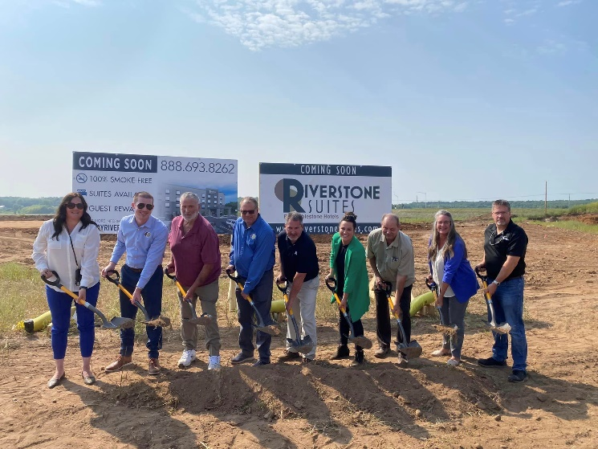
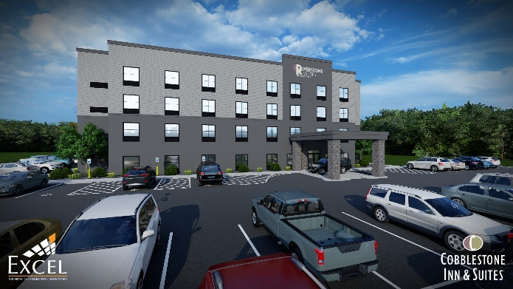
August 9, 2023 – Neenah, WI – Cobblestone Hotels celebrated the groundbreaking ceremony for their new brand, the Riverstone Suites in Chippewa Falls, Wisconsin. This is Cobblestone’s debut construction under their extended stay brand.
This event was attended by members of the Wogernese family, representatives from the Chippewa Falls Chamber of Commerce and the city of Chippewa Falls, the Cobblestone Corporate team, and members of the community. All gathered at the building site of the future Riverstone Suites, where construction has already started on the future hotel.
This extended stay brand was conceptualized by the late CEO and founder of Cobblestone Hotels, Brian Wogernese. The project has been in the works for a number of years, and all of those who gathered at the building site were there not only to celebrate this expansion of the Cobblestone brand, but also to honor the evolution of the brand pioneered by Wogernese.
Mayor Greg Hoffman shared his enthusiasm for the project, which he had been involved in from the early discussions of bringing this hotel to the city. “We always had a vision that this is what would be out here,” Hoffman said, referencing the expansive plot of land where the hotel will be constructed “and to have it actually come together is very humbling for the city and the city staff”.
The Riverstone Suites will be a 58-room facility spanning across four floors. Guests will be able to enjoy Cobblestone’s consistent amenities in the setting of a more self-paced environment than the traditional hotel experience offers. Each guestroom will contain a flat-panel television, sofa, and a kitchenette which includes a stovetop, sink, full sized refrigerator, microwave, and storage cabinets to cater the experience to guests who need long-term lodging solutions.
Attracting long-term visitors and long-term business to the Chippewa Falls area is a goal that many members of the community can get behind. "This isn’t only Chippewa Falls,” said Hoffman. “This is going to be exciting, the opportunities that this is going to bring to the whole community and the whole of Chippewa Falls”.
Jeremy Griesbach, who is the President of Development for Cobblestone Hotels, shared that “The extended stay market in hospitality has always been a grand market”. Griesback continued to explain the Riverstone concept as “an efficient apartment in one-room prototypes”, which is ideal for those planning stays ranging from days to multiple weeks.
The significance of bringing Cobblestone’s first extended stay brand to Chippewa Falls was revealed by Jeremy, who shared that the city was also home to the first Main Street hotel prototype as well as the first Wissota Chophouse, which is a restaurant brand also launched by Cobblestone. “Chippewa Falls has always been part of our identity” Griesbach explained, sharing that the late CEO of Cobblestone Hotels and his wife and partner Kim Wogernese had both grown up in the city. “Chippewa Falls, to do this here makes all the sense in the world.”
This hotel will be located at 1413 Chippewa Crossing Boulevard in the city of Chippewa Falls. Each stay grants guests access to complimentary high speed internet connections, and an onsite fitness facility. For the convenience of those staying at the hotel, an expanded Cobblestone Marketplace convenience store is located onsite, as well as a coin-operated guest laundry center. The property is being constructed by BriMark Builders and managed by Slate Hospitality Group.
Whether you are travelling for business or leisure, when you stay Cobblestone you will experience the big city quality and small-town values that each location has to offer. Visit www.staycobblestone.com for reservations and more.
To stay up to date with all of Cobblestone’s current and upcoming projects, please “like” Cobblestone Hotels on Facebook: https://www.facebook.com/cobblestonehotels/
About Cobblestone Hotels
Based in Neenah, WI Cobblestone Hotels, LLC is a leading upper-midscale hotel brand with over 169 hotels open, under construction, or in development in 29 states. The company continues to pride itself in filling the lodging needs of communities through its upper mid-scale new build brand. Signature amenities include high-speed Internet access, complimentary breakfast, convenience store, fitness centers, business centers, and more.

Cobblestone Hotels includes Cobblestone Hotels & Suites, Cobblestone Inn & Suites, Boarders Inn & Suites, Centerstone Hotels, and KeyWest Hotels. For development information please visit www.CobblestoneFranchising.com.

Cobblestone Hotels offers the Cobblestone Rewards frequent stayer program where guests receive ten points for every dollar spent, and can be redeemed as award nights, or with other redemption partners. For more information visit www.CobblestoneRewards.com

Contact: marketing@staycobblestone.com

