NEWS RELEASE
COBBLESTONE HOTELS, LLC OPENS SHELDON, IOWA
June 7, 2023 – Neenah, WI – Cobblestone Hotels announces the opening of the Cobblestone Inn & Suites in Sheldon, Iowa. This 40-guestroom hotel is located at 271 34th Avenue in the city of Sheldon, convenient to IA-60. The charming midwestern city is located near the borders of South Dakota, Nebraska, and Minnesota. Guests traveling through Northwestern Iowa will appreciate the convenience of this location to the major hubs of Sioux Falls, SD and Sioux City, IA, both of which are just over 60 miles from the hotel.
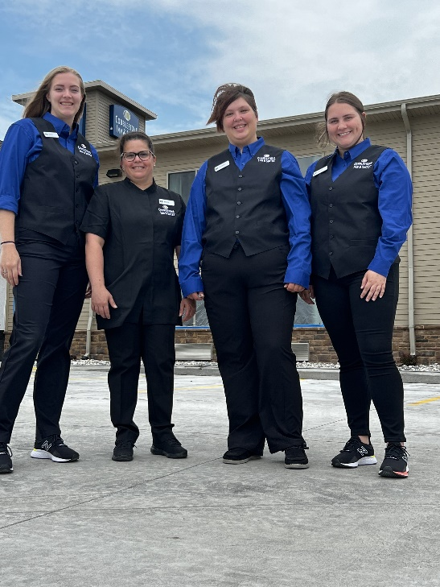
Visitors will enjoy endless opportunities to explore the city when their travels bring them to Sheldon. The Sheldon Outdoor Aquatic Center offers a swimming pool and waterslide, and more family fun can be found at one of the many public parks in the city. Unique boutique and thrift shops can be found along 9th Avenue, and the local eateries offer a wide variety of cuisines to explore. The Crossroads Pavilion Event Center, which hosts public and private events like weddings, meetings, and community interest events, is just minutes away from the hotel.
Sheldon is home to booming manufacturing and agricultural industries, and visitors will find easy access to key area businesses such as AG Processing, Inc., Maintainer Corporation of Iowa, and Rosenboom Machine & Tool. Other major area businesses include Sheldon Livestock, and Norwesco, Inc. Events at the Northwest Iowa Community College draw visitors year-round as does the RiseFest Festival Grounds where the RiseFest is held each summer. The Sanford Sheldon Medical Center is a short drive from the hotel.
The Cobblestone Inn & Suites - Sheldon offers guests classic Cobblestone amenities like coffee and tea makers, mini-refrigerators, microwaves, and flat-screen televisions in every room. A complimentary hot breakfast is offered each morning, and high-speed internet access can be found throughout the hotel. Onsite services such as coin-operated guest laundry, a business center with a computer and printer, and an onsite exercise facility are available for all who choose to Stay Cobblestone while visiting Sheldon.
Whether you’re travelling for business or leisure, you will experience the big city quality, and small-town values that each location has to offer. Visit www.CobblestoneHotels.com for reservations and additional information.
Follow us on Facebook to stay up to date on all of our new and upcoming locations at https://www.facebook.com/cobblestonehotels/
ABOUT COBBLESTONE HOTELS
Based in Neenah, WI Cobblestone Hotels, LLC is a leading upper-midscale hotel brand with over 165 hotels open, under construction, or in development in 29 states. The company continues to pride itself in filling the lodging needs of communities through its upper mid-scale new build brand. Signature amenities include high-speed Internet access, complimentary breakfast, convenience store, fitness centers, business centers, and more.
Cobblestone Hotels includes Cobblestone Hotels & Suites, Cobblestone Inn & Suites, Boarders Inn & Suites, Centerstone Hotels, and KeyWest Hotels. For development information please visit www.CobblestoneFranchising.com.
Cobblestone Hotels offers the Cobblestone Rewards frequent stayer program where guests receive ten points for every dollar spent, and can be redeemed as award nights, or with other redemption partners. For more information visit www.CobblestoneRewards.com
Contact: marketing@staycobblestone.com

