NEWS RELEASE
COBBLESTONE HOTELS, LLC OPENS MOSINEE, WISCONSIN
June 25, 2023 – Neenah, WI – Cobblestone Hotels announces the opening of the Cobblestone Hotel & Suites in Mosinee, Wisconsin. This 54-guestroom hotel is located at 216 Main Street in the city of Mosinee, just off of Interstate 39. Mosinee is located along the Wisconsin River, which feeds into Half Moon Lake to the north of the city. Mosinee is about 15 miles from Wausau and 21 miles from Stevens Point.
Guests of the Cobblestone Hotel & Suites will find convenient travel to the area by way of I-39, or State Route 153. Mosinee is home to the Central Wisconsin Airport, which hosts two major airlines and offers flight instruction services. The hotel is convenient to local marinas, boat launches, beaches, and fishing spots for those who enjoy watersports. Guests travelling to the Mosinee area for leisure will find easy access to ATV trails, boat rentals, hiking trails, and local parks. River Park, which is home to the annual Logjam festival, is under a mile away from the hotel.
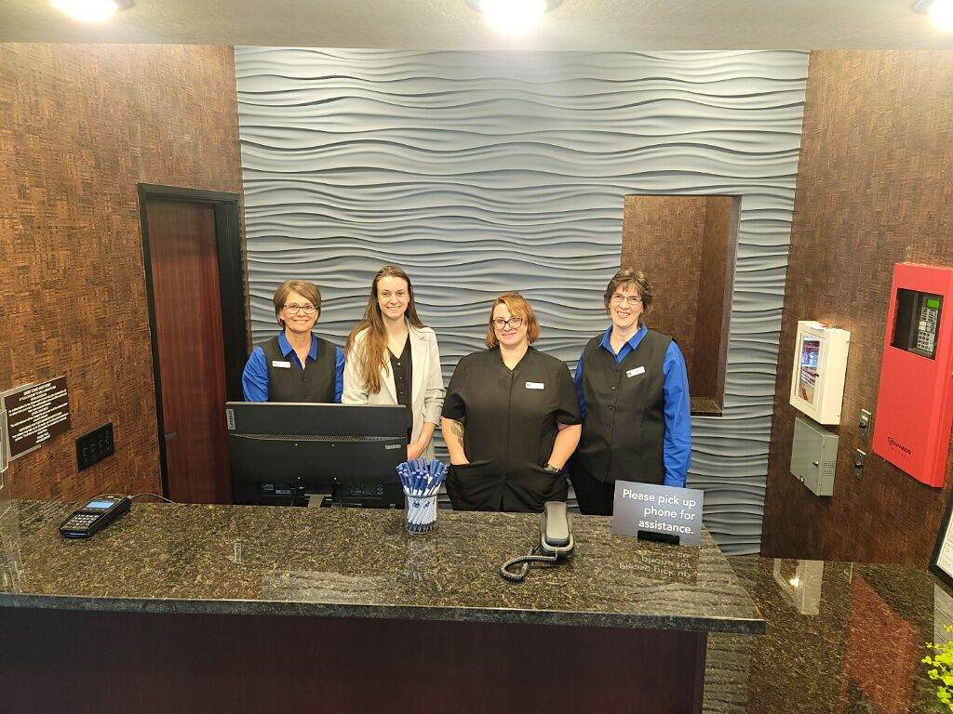
Downtown Mosinee has many local restaurants, pubs, and cafe’s that are all within minutes of the hotel. The Mosinee Brewing Company is a local favorite, as is Two’s Co Restaurant & Lounge. If you’re in the mood for a morning pick-me-up, the Mission Coffee House is located directly next to the hotel.
Visitors will find convenient access to Expera Specialty Solutions and Swiderski Equipment. The Central Wisconsin Business Park is just over 2 miles East of the hotel
The Cobblestone Hotel & Suites - Mosinee offers guests classic Cobblestone amenities like coffee and tea makers, mini-refrigerators, microwaves, and flat-screen televisions in every room. A complimentary hot breakfast is offered each morning, and high-speed internet access can be found throughout the hotel. Onsite services such as coin-operated guest laundry, a business center with a computer and printer, an indoor swimming pool, and an onsite exercise facility are available for all who choose to stay Cobblestone while visiting Mosinee.
Whether you are travelling for business or for leisure, you will experience “Big City Quality... Small Town Values” at each location. Visit www.CobblestoneHotels.com for reservations and additional information.
Follow us on Facebook to stay up to date on all of our new and upcoming locations at https://www.facebook.com/cobblestonehotels/
ABOUT COBBLESTONE HOTELS
Based in Neenah, WI Cobblestone Hotels, LLC is a leading upper-midscale hotel brand with over 168 hotels open, under construction, or in development in 29 states. The company continues to pride itself in filling the lodging needs of communities through its upper mid-scale new build brand. Signature amenities include high-speed Internet access, complimentary breakfast, convenience store, fitness centers, business centers, and more.

Cobblestone Hotels includes Cobblestone Hotels & Suites, Cobblestone Inn & Suites, Boarders Inn & Suites, Centerstone Hotels, and KeyWest Hotels. For development information please visit www.CobblestoneFranchising.com.

Cobblestone Hotels offers the Cobblestone Rewards frequent stayer program where guests receive ten points for every dollar spent, and can be redeemed as award nights, or with other redemption partners. For more information visit www.CobblestoneRewards.com

