NEWS RELEASE
COBBLESTONE HOTELS, LLC OPENS LAMAR, COLORADO
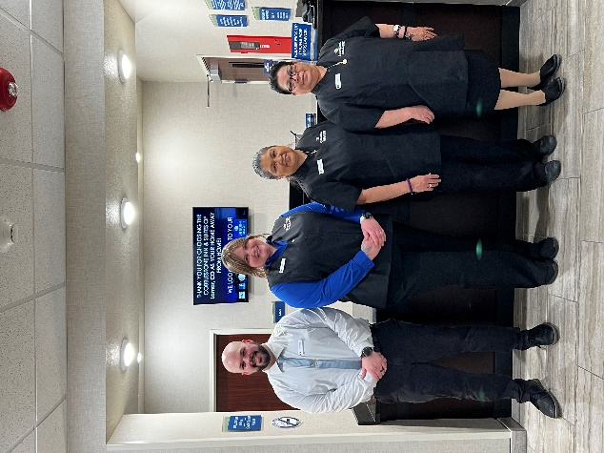
MARCH 7, 2023 – Neenah, WI – Cobblestone Hotels announces the opening of the Cobblestone Hotel & Suites in Lamar, Colorado. This 54-guestroom hotel is located at 1215 North Main Street in the city of Lamar and offers guests convenient access to Highways 50 and 287. This hotel is less than a mile away from the Arkansas River and is just under an hour’s drive from the border of Kansas.
Guests of the Cobblestone Hotel & Suites will find themselves surrounded by the quiet and rugged beauty of Southeastern Colorado. Fun for the whole family can be found at North Gateway Park, which offers paddleboard and kayak rentals as well as fishing and swimming opportunities. Guests will also appreciate the opportunity to immerse themselves in the culture of the area while in town. Local gems such as the Big Timber Museum and the Petrified Wood Gas Station are must-sees, or one could take a day trip to nearby Bent’s Old Fort National Historic Site to learn more about the area’s rich historical roots.
Visitors may appreciate the hotel’s proximity to a number of local businesses, such as Colorado Mills, 4 Rivers Equipment, Prowers Medical Center, and many more. Lamar is also home to Lamar Community College, which holds classes year-round for local students pursuing higher education.
The Cobblestone Hotel & Suites - Lamar offers guests classic Cobblestone amenities like coffee and tea makers, mini-refrigerators, microwaves, and flat-screen televisions in every room. A complimentary hot breakfast is offered each morning, and high-speed internet access can be enjoyed throughout the hotel. Onsite services such as coin-operated guest laundry, a business center complete with a computer and printer, an onsite exercise facility, and an indoor pool are available for all those who choose to stay Cobblestone when visiting Lamar.
Whether you’re travelling for business or leisure, you will experience the big city quality, and small-town values that each location has to offer. Visit www.CobblestoneHotels.com for reservations and additional information.
Follow us on Facebook to stay up to date on all of our new and upcoming locations at https://www.facebook.com/cobblestonehotels/
ABOUT COBBLESTONE HOTELS
Based in Neenah, WI Cobblestone Hotels, LLC is a leading upper-midscale hotel brand with over 165 hotels open, under construction, or in development in 28 states. The company continues to pride itself in filling the lodging needs of communities through its upper mid-scale new build brand. Signature amenities include high-speed Internet access, complimentary breakfast, convenience store, fitness centers, business centers, and more.
Cobblestone Hotels includes Cobblestone Hotels & Suites, Cobblestone Inn & Suites, Boarders Inn & Suites, Centerstone Hotels, and KeyWest Hotels. For development information please visit www.CobblestoneFranchising.com.
Cobblestone Hotels offers the Cobblestone Rewards frequent stayer program where guests receive ten points for every dollar spent, and can be redeemed as award nights, or with other redemption partners. For more information visit www.CobblestoneRewards.com
Contact: marketing@staycobblestone.com

