NEWS RELEASE
COBBLESTONE HOTELS, LLC OPENS DE PERE, WISCONSIN
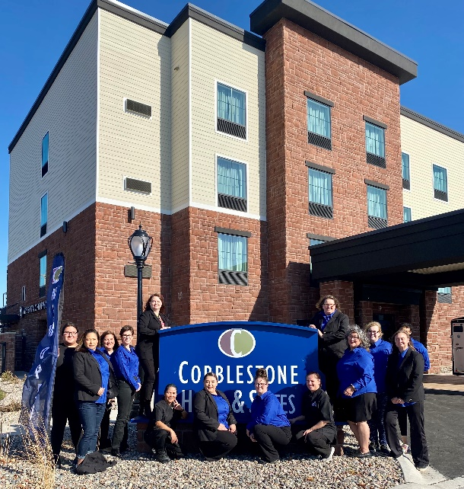
November 4, 2022 – Neenah, WI – Cobblestone Hotels announces the opening of the Cobblestone Hotel & Suites in De Pere, Wisconsin.
Located at 499 Main Avenue in De Pere, this 60-guestroom hotel is located near everything that Brown County has to offer. This hotel will support the lodging needs of travelers who find themselves in this metropolitan city on the Fox River.
Visitors will find endless opportunities to immerse themselves in the culture of the city of De Pere when they stay at the Cobblestone Hotel & Suites – De Pere. Popular area attractions include the Resch Center, St. Norbert’s College, the University of Wisconsin – Green Bay, and Lambeau Field, home to the legendary Green Bay Packers. Within walking distance of the hotel is the De Pere River Walk and Viewing Pier, which offers stunning views of the Fox River. The city of De Pere is known for its proximity to several freshwater access points, where visitors can participate in boating, swimming, and fishing activities while staying in the city.
Additional area businesses include the Oneida Casino, Thilmany Nicolet Mill, WEL Companies, Green Bay Packaging Inc., and NCLED. Guests will find easy access to HSHS St. Vincent Hospital and Austin Straubel Airport.
This hotel offers guests the services and amenities they need to enjoy a comfortable stay. Guestroom amenities include in-room coffee and tea makers, mini refrigerators, microwaves, luxury linens, and flat-screen televisions. A complimentary breakfast is offered daily, and high-speed internet access can be enjoyed throughout the hotel. The Cobblestone Hotel & Suites –De Pere also sports an indoor pool, onsite convenience store, and will soon be offering onsite dining at the elegant Wissota Chophouse.
Whether you’re travelling for business or leisure, you will experience the big city quality, and small-town values that each location has to offer. Visit www.CobblestoneHotels.com for reservations and additional information.
Follow us on Facebook to stay up to date on all of our new and upcoming locations at https://www.facebook.com/cobblestonehotels/
ABOUT COBBLESTONE HOTELS
Based in Neenah, WI Cobblestone Hotels, LLC is a leading upper-midscale hotel brand with over 165 hotels open, under construction, or in development in 28 states. The company continues to pride itself in filling the lodging needs of communities through its upper mid-scale new build brand. Signature amenities include high-speed Internet access, complimentary breakfast, convenience store, fitness centers, business centers, and more.
Cobblestone Hotels includes Cobblestone Hotels & Suites, Cobblestone Inn & Suites, Boarders Inn & Suites, Centerstone Hotels, and KeyWest Hotels. For development information please visit www.CobblestoneFranchising.com.
Cobblestone Hotels offers the Cobblestone Rewards frequent stayer program where guests receive ten points for every dollar spent, and can be redeemed as award nights, or with other redemption partners. For more information visit www.CobblestoneRewards.com
Contact: marketing@staycobblestone.com

