NEWS RELEASE
COBBLESTONE HOTELS, LLC BREAKS GROUND IN WICKENBURG, ARIZONA
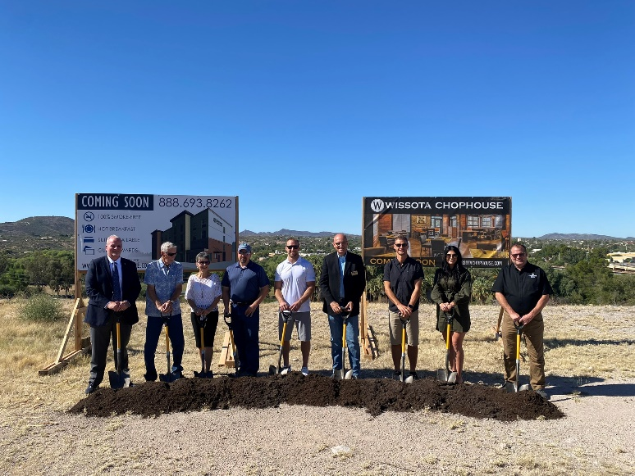
October 12, 2022 – Neenah, WI – Cobblestone Hotels celebrated the groundbreaking of their new hotel and Wissota Chophouse that is coming soon to Wickenburg, Arizona.
Representatives of area businesses gathered alongside town officials to celebrate the new addition to the town of Wickenburg. Members of the Wickenburg Chamber of Commerce were in attendance, as well as representatives from Frontier Bank and members of the investment group Wickenburg Hotel Group, LLC.
Mayor Rui Pereira was the first to speak at the groundbreaking. He shared his enthusiasm for the project, noting that he is a “recovering hotel guy” who has been familiar with the Cobblestone brand for nearly a decade. Pereira believes that the hotel and chophouse will be an asset to area businesses and the community of Wickenburg, noting that “It’s going to reap rewards for many, many, many years to come”.
Geri Fair, with the Wickenburg Chamber of Commerce, spoke about the economic impact that this hotel is expected to have on the town, addressing the investors, financiers, and the Cobblestone team when she said, “All these businesses are behind you”.
The Cobblestone Hotel & Suites - Wickenburg will be an 86 room, four-story building modeled after the Cobblestone Main Street prototype. Guests will be able to enjoy Cobblestone’s consistent amenities, such as 24-hour Starbuck’s Coffee service, high-speed internet access, and a complimentary hot breakfast each morning. Guestrooms will be equipped with flat-panel televisions, microwaves, refrigerators, and in-room personal coffee brewers.
Brian Wogernese, CEO of Cobblestone Hotels, expressed that the establishment of this new hotel and chophouse in Wickenburg marks “a huge step forward for both the city of Wickenburg and the Cobblestone Brand”.
The Cobblestone Hotel & Suites will also host elegant onsite dining at the Wissota Chophouse, which is known for its extensive craft beer selection and innovative menu options. This hotel will also have an onsite business center, fitness center, meeting room, and outdoor pool to maximize the experience of travelers who find themselves in Wickenburg.
The Cobblestone team was excited to be attending the groundbreaking of their first hotel in the state of Arizona, with many representatives travelling to the event from their headquarters across the country. Jeremy Griesbach, President of Development for Cobblestone Hotels, said that “our specialty and our focus are towns like Wickenburg, Arizona”, noting that the small city had been in need of quality lodging for years.
The Cobblestone Hotel & Suites will be located at 575 Bass Road in the town of Wickenburg. The property is being constructed by BriMark Builders and managed by Slate Hospitality Group.
For updates on the progress of this location and others, please “like” Cobblestone Hotels on Facebook: https://www.facebook.com/cobblestonehotels/.
About Cobblestone Hotels
Based in Neenah, WI Cobblestone Hotels, LLC is a leading upper-midscale hotel brand with over 165 hotels open, under construction, or in development in 28 states. The company continues to pride itself in filling the lodging needs of communities through its upper mid-scale new build brand. Signature amenities include high-speed Internet access, complimentary breakfast, convenience store, fitness centers, business centers, and more.

Cobblestone Hotels includes Cobblestone Hotels & Suites, Cobblestone Inn & Suites, Boarders Inn & Suites, Centerstone Hotels, and KeyWest Hotels. For development information please visit www.CobblestoneFranchising.com.

Cobblestone Hotels offers the Cobblestone Rewards frequent stayer program where guests receive ten points for every dollar spent, and can be redeemed as award nights, or with other redemption partners. For more information visit www.CobblestoneRewards.com

Contact: marketing@staycobblestone.com

