NEWS RELEASE
COBBLESTONE HOTELS, LLC SIGNS SHELDON, IA
September 2, 2022 – Neenah, WI – Cobblestone Hotels announces their continued growth in Iowa with the signing of the coming soon Cobblestone Inn & Suites in Sheldon with Cobblestone Sheldon, LLC.
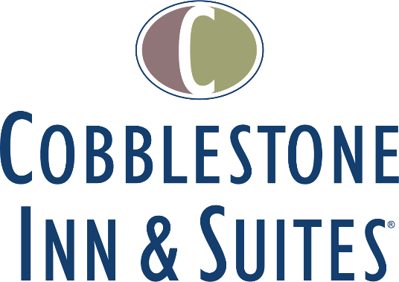
This Cobblestone Hotel & Suites location will host 40 tastefully designed, modern guestrooms. The hotel will feature the Cobblestone Marketplace-branded onsite convenience store, onsite exercise facility, business center and an onsite lounge. This location will also offer a hot complimentary breakfast served each day, Seattle’s Best coffee service, and high-speed internet access throughout the hotel.
Guestrooms are perfectly tailored to meet the needs of modern travelers, while tastefully designed with an element of contemporary elegance. Amenities include flat-screen TVs, additional recharge outlets for electronics, microwaves, mini refrigerators, in-room coffee brewers, hairdryers, iron and ironing boards, desks, luxury linens, and bathroom essentials.
For updates on the progress of this location and others, please “like” Cobblestone Hotels on Facebook: https://www.facebook.com/cobblestonehotels/
Whether you are traveling for business or for leisure, you will experience the big city quality, and small town values that each location has to offer. Visit www.CobblestoneHotels.com for reservations or for more information.
About Cobblestone Hotels
Based in Neenah, WI Cobblestone Hotels, LLC is a leading upper-midscale hotel brand with over 165 hotels open, under construction, or in development in 28 states. The company continues to pride itself in filling the lodging needs of communities through its upper mid-scale new build brand. Signature amenities include high-speed Internet access, complimentary breakfast, convenience store, fitness centers, business centers, and more.

Cobblestone Hotels includes Cobblestone Hotels & Suites, Cobblestone Inn & Suites, Boarders Inn & Suites, Centerstone Hotels, and KeyWest Hotels. For development information please visit www.CobblestoneFranchising.com.

Cobblestone Hotels offers the Cobblestone Rewards frequent stayer program where guests receive ten points for every dollar spent, and can be redeemed as award nights, or with other redemption partners. For more information visit www.CobblestoneRewards.com

Contact: marketing@staycobblestone.com

