NEWS RELEASE
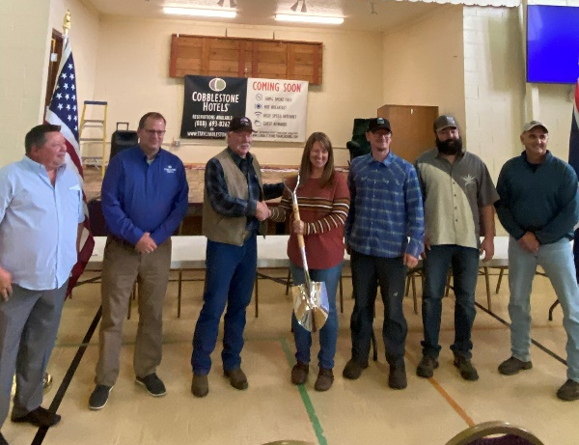
COBBLESTONE HOTELS, LLC BREAKS GROUND IN ALPINE, WYOMING
September 14, 2022 – Neenah, WI – Cobblestone Hotels celebrated the groundbreaking of their new hotel that is coming soon to the town of Alpine, Wyoming.
Members of the community and representatives of the larger Lincoln County gathered at the groundbreaking ceremony to express their enthusiasm about this project, which will support the lodging needs of key industries in the area. Officials from the town of Alpine as well as the Lincoln County Economic Development board were present to voice their continued support for bringing the Cobblestone Hotel & Suites to Alpine.
First to speak was Tim Shefchik, Vice President of Development for Cobblestone Hotels. Shefchik stated that throughout his travels in Western Wyoming, he “Put the word out there that there’s an option for rural America within the hotel industry, and that’s Cobblestone Hotels”.
Shefchik’s words found their way to Mayor Kennis Lutz, who commented that “It’s about time!” when speaking about the project. Lutz and his fellow city officials had been looking to bring lodging to Alpine for some time, and found a great partner in Cobblestone, who specialize in bringing lodging options to rural communities.
This hotel is expected to benefit the economy of Alpine greatly, in the form of supporting the area tourism and construction industries. Jeremy Larsen, town Councilman and member of the Lincoln County Economic Development Board, noted that “It’s a project like this that is really an incubator for a better community”. Pride in the community of Alpine was a theme later echoed by member of the Alpine Wyoming Hotel, LLC investment group Mick McCullough, who was optimistic about the benefit that this new hotel will bring to Alpine.
The Cobblestone Hotel & Suites - Alpine will be a 66 room, three story building that will offer guests access to Cobblestone signature services and amenities. Guests will be able to enjoy 24-hour Seattle’s Best Coffee service, high-speed internet access, and a complimentary hot breakfast each morning. Guestrooms will be equipped with flat-panel televisions, microwaves, refrigerators, and in-room personal coffee brewers.
The Cobblestone Hotel & Suites – Alpine will also host an indoor pool, business center, fitness center and meeting room to meet the needs of both locals and travelers who are seeking lodging in the Alpine area.
Jeremy Griesbach, President of Development for Cobblestone Hotels, spoke about the growth of the brand, noting that this hotel will be the 5th in the state of Wyoming. “What that growth has proven to me, is the concept that Brian Wogernese came up with back in the day, of bringing quality lodging to small town America”.
The Cobblestone Hotel & Suites will be located at 111 Greys River Road in the town of Alpine. The hotel is being constructed by BriMark Builders and managed by Slate Hospitality Group.
For updates on the progress of this location and others, please “like” Cobblestone Hotels on Facebook: https://www.facebook.com/cobblestonehotels/.
About Cobblestone Hotels
Based in Neenah, WI Cobblestone Hotels, LLC is a leading upper-midscale hotel brand with over 165 hotels open, under construction, or in development in 28 states. The company continues to pride itself in filling the lodging needs of communities through its upper mid-scale new build brand. Signature amenities include high-speed Internet access, complimentary breakfast, convenience store, fitness centers, business centers, and more.

Cobblestone Hotels includes Cobblestone Hotels & Suites, Cobblestone Inn & Suites, Boarders Inn & Suites, Centerstone Hotels, and KeyWest Hotels. For development information please visit www.CobblestoneFranchising.com.

Cobblestone Hotels offers the Cobblestone Rewards frequent stayer program where guests receive ten points for every dollar spent, and can be redeemed as award nights, or with other redemption partners. For more information visit www.CobblestoneRewards.com

Contact: marketing@staycobblestone.com

