NEWS RELEASE
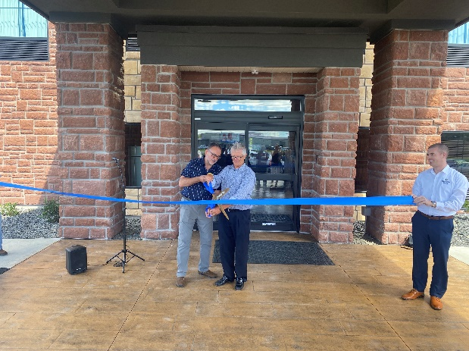
COBBLESTONE HOTELS, LLC CELEBRATES RIBBON CUTTING AT THE COBBLESTONE HOTEL & SUITES IN INTERNATIONAL FALLS, MINNESOTA
August 11, 2022 – Neenah, WI – Cobblestone Hotels celebrated the grand opening and official ribbon cutting for their new location in International Falls, MN on August 10, 2022.
The Cobblestone Hotel & Suites is located at 1 Memorial Drive in the charming city of International Falls, just 10 minutes away from the United States-Canadian border. The four-story hotel is comprised of 87 guestrooms, and boasts the consistent amenities of the Cobblestone brand, such as high-speed internet access, a complimentary hot breakfast each morning, and 24-hour Starbucks coffee service for guests to enjoy.
Members of the ownership group reflected on the journey of bringing Cobblestone to International Falls and extended their appreciation for those along the way who played a part in bringing this project to fruition.
Lawrence Maksymetz, member of IFalls Group, LLC, spoke on the benefit that a full-service hotel such as this one will bring to the city. Maksymetz noted that “I think with a facility like this, people will start coming back to International Falls”.
Other members of the community of International Falls were present to express their excitement about the new hotel. Harvey Droba, Mayor of the City of International Falls, stated that “We have a community that has this feeling sometimes of wait until I see it, I’ll believe it when I see it. Well ladies and gentlemen, behind me is something for us to see, something to showcase, and it’s the first thing you’re seeing when you come into International Falls”.
The Cobblestone Hotel & Suites – International Falls hosts an indoor pool, business center, meeting room, convenience store, exercise facility, and onsite restaurant.
Guestrooms are perfectly tailored to meet the needs of the modern traveler, while designed with an element of contemporary elegance. In-room amenities include flat-screen TVs, additional recharge outlets for electronics, microwaves, mini-refrigerators, in-room coffee brewers, hairdryers, iron and ironing boards, sturdy desks, luxury linens, and bathroom essentials.
Whether you are travelling for business or leisure, when you stay Cobblestone you will experience the big city quality and small-town values that each location has to offer. Visit www.staycobblestone.com for reservations and more.
To stay up to date with all of Cobblestone’s current and upcoming projects, please “like” Cobblestone Hotels on Facebook: https://www.facebook.com/cobblestonehotels/
About Cobblestone Hotels
Based in Neenah, WI Cobblestone Hotels, LLC is a leading upper-midscale hotel brand with over 165 hotels open, under construction, or in development in 28 states. The company continues to pride itself in filling the lodging needs of communities through its upper mid-scale new build brand. Signature amenities include high-speed Internet access, complimentary breakfast, convenience store, fitness centers, business centers, and more.

Cobblestone Hotels includes Cobblestone Hotels & Suites, Cobblestone Inn & Suites, Boarders Inn & Suites, Centerstone Hotels, and KeyWest Hotels. For development information please visit www.CobblestoneFranchising.com.

Cobblestone Hotels offers the Cobblestone Rewards frequent stayer program where guests receive ten points for every dollar spent, and can be redeemed as award nights, or with other redemption partners. For more information visit www.CobblestoneRewards.com

Contact: marketing@staycobblestone.com

