NEWS RELEASE
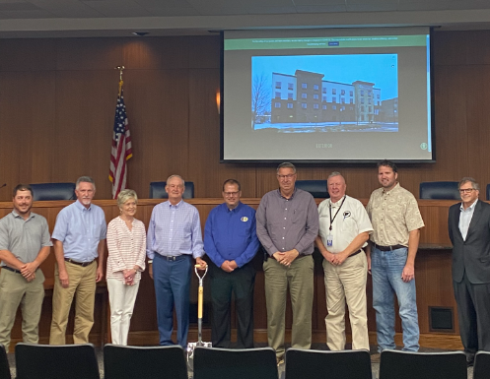
COBBLESTONE HOTELS, LLC BREAKS GROUND IN CULLMAN, ALABAMA
August 30, 2022 – Neenah, WI – Cobblestone Hotels celebrated the groundbreaking of their new hotel that is coming soon to Cullman, Alabama.
Members of the community of Cullman gathered at Cullman City Hall to celebrate the groundbreaking ceremony of the Cobblestone Hotel & Suites, including representatives from the Cullman Area Chamber of Commerce, Cullman Economic Development Agency, the Opportunity Cullman investment group, and city officials. Themes of teamwork, community, and progress were echoed by each speaker who took to the stand to voice their enthusiasm for this project.
Keith Varden, President of the Cullman Area Chamber of Commerce, was the first to speak at the Tuesday gathering. Varden spoke on the economic benefit of bringing the Cobblestone Hotel & Suites to Cullman’s downtown area, where it would support the lodging needs of Cullman’s industrial area and draw more traffic to local businesses. "The need for this is great.”, said Varden, who also noted that this hotel will be the first in downtown Cullman.
Next to speak was Jeremy Griesbach, President of Development for Cobblestone Hotels. Griesbach also commented on the need that exists for a hotel like this one in the downtown area of Cullman, to support area businesses and sporting events in the downtown area. “I see the vision now” he said, regarding the members in attendance who had helped to bring Cobblestone to Cullman. He thanked Mayor Woody Jacobs, as well as members of the economic development team and Cullman area chamber for their push to make the Cobblestone Hotel & Suites – Cullman a reality.

This hotel will be a 63 room, four story building modeled after the Cobblestone Main Street prototype. Guests will be able to enjoy Cobblestone’s consistent amenities, such as 24-hour Starbucks Coffee service, high-speed internet access, onsite restaurant and bar, and a complimentary hot breakfast each morning. Guestrooms will be equipped with flat-panel televisions, microwaves, refrigerators, and in-room personal coffee brewers.
The Wissota Chophouse, a high-end steakhouse known for its quality dishes and extensive list of microbrews, will be a key feature of this hotel. The Cobblestone Hotel & Suites – Cullman will also host an indoor pool, business center, and board room to meet the needs of travelers coming to Ottumwa.
The Cobblestone Hotel & Suites – Cullman will also host an outdoor pool, business center, 24-hour convenience store, fitness center and meeting room to meet the needs of both locals and travelers who are seeking lodging in the Cullman area.
Mayor Woody Jacobs took a moment to comment on the cooperation and dedication demonstrated by each of the passionate groups who worked to bring this hotel to Cullman. “When a project comes to Cullman, we all work it” said Jacobs, addressing the Cullman community as a whole.
Brian Wogernese, CEO of Cobblestone Hotels, expressed his enthusiasm about this project and the growth that it represents for Cobblestone Hotels as a brand. “This event marks Cobblestone’s first construction in the state of Alabama, and we could not be more excited to be joining the community.” said Wogernese.
The Cobblestone Hotel & Suites will be located at 1835 Main Avenue SW in the city of Cullman. The property is being constructed by BriMark Builders and managed by Slate Hospitality Group.
For updates on the progress of this location and others, please “like” Cobblestone Hotels on Facebook: https://www.facebook.com/cobblestonehotels/.
About Cobblestone Hotels
Based in Neenah, WI Cobblestone Hotels, LLC is a leading upper-midscale hotel brand with over 165 hotels open, under construction, or in development in 28 states. The company continues to pride itself in filling the lodging needs of communities through its upper mid-scale new build brand. Signature amenities include high-speed Internet access, complimentary breakfast, convenience store, fitness centers, business centers, and more.

Cobblestone Hotels includes Cobblestone Hotels & Suites, Cobblestone Inn & Suites, Boarders Inn & Suites, Centerstone Hotels, and KeyWest Hotels. For development information please visit www.CobblestoneFranchising.com.

Cobblestone Hotels offers the Cobblestone Rewards frequent stayer program where guests receive ten points for every dollar spent, and can be redeemed as award nights, or with other redemption partners. For more information visit www.CobblestoneRewards.com

Contact: marketing@staycobblestone.com

