NEWS RELEASE
COBBLESTONE HOTELS, LLC SIGNS WINTERS, TEXAS
June 13, 2022 – Neenah, WI – Cobblestone Hotels announces their continued growth in Texas with the signing of the coming soon Cobblestone Inn & Suites - Winters, with Winters Hotel Group, LLC.

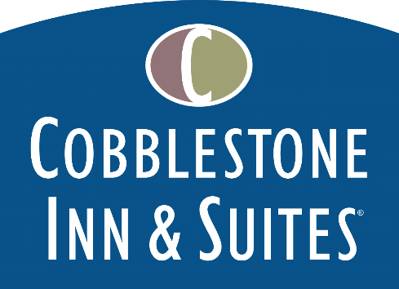
The Cobblestone Inn & Suites – Winters will hold 35 elegantly designed, modern guestrooms spanning across two floors. This hotel will feature many of Cobblestone’s signature amenities, including the 24-hour Cobblestone Marketplace, a business center, an onsite Cobblestone lounge, and fitness center. This location will also offer a hot complimentary breakfast served daily, Seattle’s Best coffee service, and high-speed internet access throughout the hotel.
Guestrooms are perfectly tailored to meet the needs of modern travelers, tastefully designed with an element of contemporary elegance. Amenities include flat-screen TVs, additional recharge outlets for electronics, microwaves, mini refrigerators, in-room coffee brewers, hairdryers, iron & ironing boards, desks, luxury linens, and bathroom essentials.
For updates on the progress of this location and others, please “like” Cobblestone Hotels on Facebook: https://www.facebook.com/cobblestonehotels/
About Cobblestone Hotels
Based in Neenah, WI Cobblestone Hotels, LLC is a leading upper-midscale hotel brand with over 160 hotels open, under construction, or in development in 28 states. The company continues to pride itself in filling the lodging needs of communities through its upper mid-scale new build brand. Signature amenities include high-speed Internet access, complimentary breakfast, convenience store, fitness centers, business centers, and more.

Cobblestone Hotels includes Cobblestone Hotels & Suites, Cobblestone Inn & Suites, Boarders Inn & Suites, Centerstone Hotels, and KeyWest Hotels. For development information please visit www.CobblestoneFranchising.com.

Cobblestone Hotels offers the Cobblestone Rewards frequent stayer program where guests receive ten points for every dollar spent, and can be redeemed as award nights, or with other redemption partners. For more information visit www.CobblestoneRewards.com

Contact: marketing@staycobblestone.com

