NEWS RELEASE
COBBLESTONE HOTELS, LLC OPENS WATERLOO, IOWA
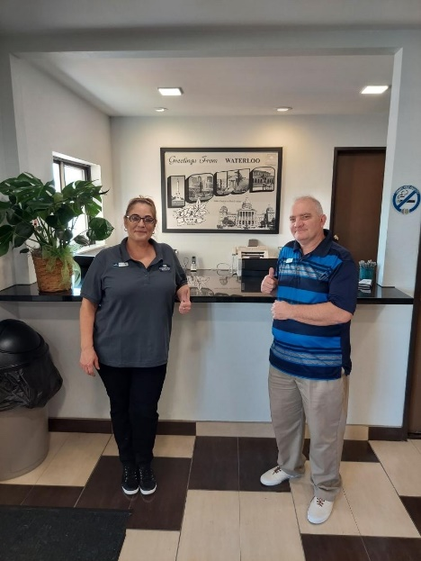
May 31, 2022 – Neenah, WI – Cobblestone Hotels is excited to announce the opening of the Boarders Inn & Suites in Waterloo, Iowa.
You will find the hotel at 1825 La Porte Road in Waterloo. Offering easy access to and from I-380 and the Waterloo Regional Airport, this 63-guestroom hotel will host guests travelling to and from the Waterloo/Cedar Falls metropolitan area.
Located in the seat of Black Hawk County, Waterloo is a booming city centered around the Cedar River. Waterloo offers travelers many opportunities to experience the city their way. A popular destination for families is the Lost Island Theme Park & Waterpark, which is only a five-minute drive from the hotel. Other must–sees include George Wyn State Park and the John Deere Tractor Museum. One might also find themselves in the area due to Waterloo’s proximity to John Deere Waterloo Operations, the University of Northern Iowa, or the MercyOne Waterloo Medical Center. Whatever reason you have for coming to Waterloo, you will find a dozen more to make you want to extend your stay when you stay at the Boarders Inn & Suites – Waterloo.
Our 100% smoke-free hotel offers guests everything they need to ensure a comfortable stay. Guestroom amenities include in-room coffee and tea makers, mini fridges, microwaves, and flat-panel televisions. Contnental breakfast is offered daily, and high-speed internet can be enjoyed throughout the hotel.
Whether you are travelling for business or for leisure, you will experience the big city quality, and small town values that each location has to offer. Visit www.CobblestoneHotels.com for reservations or for more information.
Follow us on Facebook to stay up to date on all of our new and upcoming locations at https://www.facebook.com/cobblestonehotels/
About Cobblestone Hotels
Based in Neenah, WI Cobblestone Hotels, LLC is a leading upper-midscale hotel brand with over 160 hotels open, under construction, or in development in 28 states. The company continues to pride itself in filling the lodging needs of communities through its upper mid-scale new build brand. Signature amenities include high-speed Internet access, complimentary breakfast, convenience store, fitness centers, business centers, and more.
Cobblestone Hotels includes Cobblestone Hotels & Suites, Cobblestone Inn & Suites, Boarders Inn & Suites, Centerstone Hotels, and KeyWest Hotels. For development information please visit www.CobblestoneFranchising.com.
Cobblestone Hotels offers the Cobblestone Rewards frequent stayer program where guests receive ten points for every dollar spent, and can be redeemed as award nights, or with other redemption partners. For more information visit www.CobblestoneRewards.com

Contact: marketing@staycobblestone.com

