NEWS RELEASE
COBBLESTONE HOTELS, LLC OPENS INTERNATIONAL FALLS, MINNESOTA
June 17, 2022 – Neenah, WI – Cobblestone Hotels announces the opening of the Cobblestone Hotel & Suites in International Falls, Minnesota.
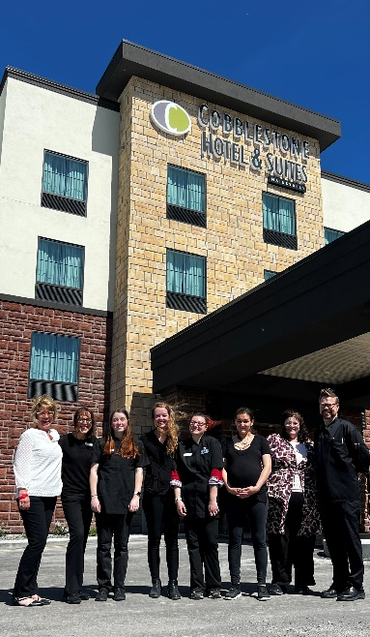
Located at 1 Memorial Drive in International Falls, this 87-guestroom hotel is located just off North Highway 53 and is less than one mile from the United States/Canadian border. Located in the county seat of Koochiching County, this hotel will support the lodging needs of travelers who find themselves in this beautiful border city.
Travelers may find themselves in the International Falls area for its proximity to the International Bridge, or for the city’s convenient access to the gateway to Canada at Fort Frances, Ontario.
Opportunities for outdoor fun can be found at Smokey Bear Park, the expansive Voyageurs National Park, or Ranier City Beach. Be sure to stop by the Cantilever Distillery to visit their unique cocktail room, or take a picture with Big Vic, a towering local landmark.
Area businesses include Coca-Cola, PCA Packaging, and M D & W Railway. Additional institutions that guests will find easily accessible from the hotel include Falls Memorial Hospital, Falls International Airport, and the Rainy River Community College. With ample opportunities to explore everything that the area has to offer, you’ll find plenty to do both inside and outside of the Cobblestone Hotel & Suites – International Falls.
This hotel offers guests the services and amenities they need to enjoy a comfortable stay. Guestroom amenities include in-room coffee and tea makers, mini refrigerators, microwaves, luxury linens, and flat-screen televisions. A complimentary breakfast is offered daily, and high-speed internet access can be enjoyed throughout the hotel. The Cobblestone Hotel & Suites – International Falls also sports an indoor pool, onsite convenience store, business center, exercise facility, and a meeting room for the enjoyment of all those who choose to stay Cobblestone while visiting International Falls.
Whether you’re travelling for business or leisure, you will experience the big city quality, and small-town values that each location has to offer. Visit www.CobblestoneHotels.com for reservations and additional information.
Follow us on Facebook to stay up to date on all of our new and upcoming locations at https://www.facebook.com/cobblestonehotels/
ABOUT COBBLESTONE HOTELS
Based in Neenah, WI Cobblestone Hotels, LLC is a leading upper-midscale hotel brand with over 160 hotels open, under construction, or in development in 28 states. The company continues to pride itself in filling the lodging needs of communities through its upper mid-scale new build brand. Signature amenities include high-speed Internet access, complimentary breakfast, convenience store, fitness centers, business centers, and more.
Cobblestone Hotels includes Cobblestone Hotels & Suites, Cobblestone Inn & Suites, Boarders Inn & Suites, Centerstone Hotels, and KeyWest Hotels. For development information please visit www.CobblestoneFranchising.com.
Cobblestone Hotels offers the Cobblestone Rewards frequent stayer program where guests receive ten points for every dollar spent, and can be redeemed as award nights, or with other redemption partners. For more information visit www.CobblestoneRewards.com
Contact: marketing@staycobblestone.com

