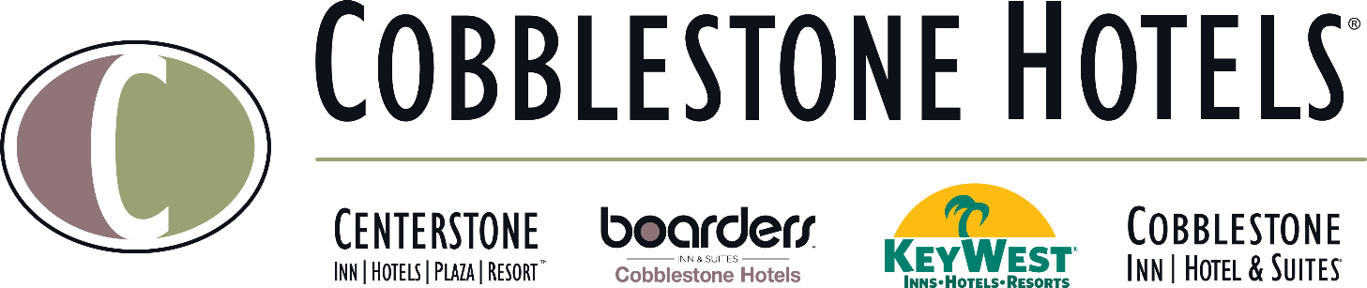

NEWS RELEASE
COBBLESTONE HOTELS, LLC SIGNS WATERLOO, IOWA
December 30, 2021 – Neenah, WI – Cobblestone Hotels announced the signing of the coming soon Boarders Inn & Suites in Waterloo, IA.
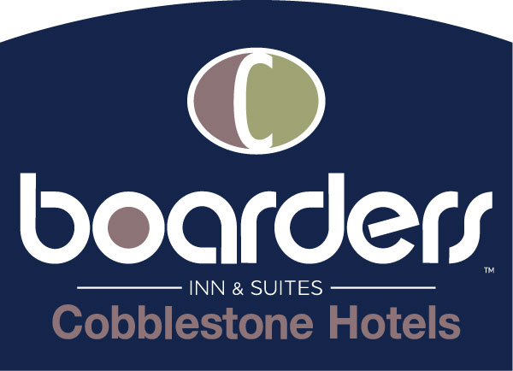
The Boarders Inn & Suites will feature breakfast, Wi-Fi, and more. The hotel will feature an array of room types that include flat screen televisions, a microwave and refrigerator, and Seattle’s Best Coffee.
For updates on the progress of this location and others, please “like” Cobblestone Hotels on Facebook: https://www.facebook.com/cobblestonehotels/
Whether you are traveling for business or for leisure, you will experience the big city quality, and small town values that each location has to offer. Visit www.CobblestoneHotels.com for reservations or for more information.
About Cobblestone Hotels
Based in Neenah, WI Cobblestone Hotels, LLC is a leading upper-midscale hotel brand with over 160 hotels open, under construction, or in development in 29 states. The company continues to pride itself in filling the lodging needs of communities through its upper mid-scale new build brand. Signature amenities include high-speed Internet access, complimentary breakfast, convenience store, fitness centers, business centers, and more.

Cobblestone Hotels includes Cobblestone Hotels & Suites, Cobblestone Inn & Suites, Boarders Inn & Suites, Centerstone Hotels, and KeyWest Hotels. For development information please visit www.CobblestoneFranchising.com.

Cobblestone Hotels offers the Cobblestone Rewards frequent stayer program where guests receive ten points for every dollar spent, and can be redeemed as award nights, or with other redemption partners. For more information visit www.CobblestoneRewards.com

Contact: marketing@staycobblestone.com

