NEWS RELEASE
COBBLESTONE HOTELS, LLC CELEBRATES THE OPENING OF SUPERIOR, WISCONSIN
December 30, 2021 – NEENAH, WISCONSIN – Cobblestone Hotels opened another location in their home state of Wisconsin, nestled on the western tip of the Great Lake Superior.
The Cobblestone Hotel & Suites is downtown in the heart of Superior next at 1102 Tower Ave. The four-story hotel has 60 guest rooms, an indoor pool, fitness center, meeting room, and business center. Superior is known for the incredible scenery, rich history, rare attractions, and year-round recreational opportunities.
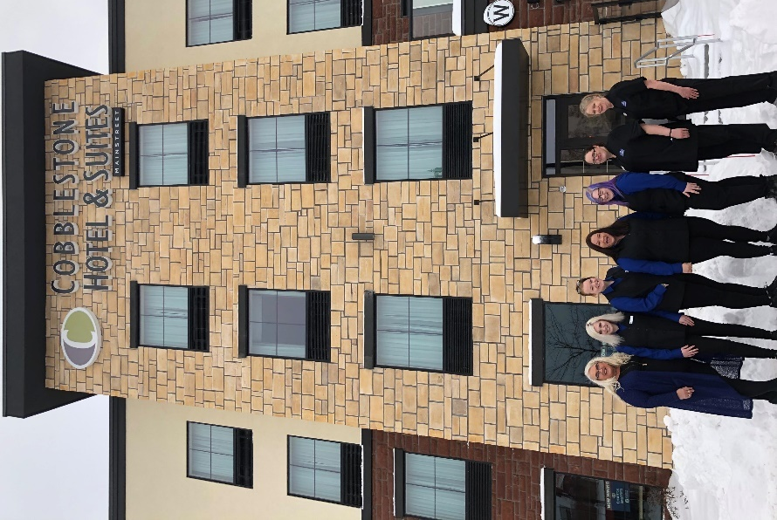
The hotel additionally features the brand’s consistent amenities such as an onsite convenience store, complimentary high-speed internet access, on-site guest laundry, Starbucks Coffee, and a complimentary breakfast served daily. The new hotel will feature Wissota Chophouse, a steakhouse and full bar, coming in 2022.
Guestrooms are perfectly tailored to meet the needs of modern travelers, while tastefully designed with an element of contemporary elegance. Amenities include flat-screen TVs, additional recharge outlets for electronics, microwaves, mini refrigerators, in-room coffee brewers, hairdryers, iron and ironing boards, desks, luxury linens, and bathroom essentials.
For updates please “like” Cobblestone Hotels on Facebook: https://www.facebook.com/cobblestonehotels/
Whether you are traveling for business or for leisure, you will experience the big city quality, and small town values that each location has to offer. Visit www.CobblestoneHotels.com for reservations or for more information.
About Cobblestone Hotels
Based in Neenah, WI Cobblestone Hotels, LLC is a leading upper-midscale hotel brand with over 160 hotels open, under construction, or in development in 29 states. The company continues to pride itself in filling the lodging needs of communities through its upper mid-scale new build brand. Signature amenities include high-speed Internet access, complimentary breakfast, convenience store, fitness centers, business centers, and more.

Cobblestone Hotels includes Cobblestone Hotels & Suites, Cobblestone Inn & Suites, Boarders Inn & Suites, Centerstone Hotels, and KeyWest Hotels. For development information please visit www.CobblestoneFranchising.com.

Cobblestone Hotels offers the Cobblestone Rewards frequent stayer program where guests receive ten points for every dollar spent, and can be redeemed as award nights, or with other redemption partners. For more information visit www.CobblestoneRewards.com

Contact: marketing@staycobblestone.com

