NEWS RELEASE
COBBLESTONE HOTELS, LLC CELEBRATES RIBBON CUTTING IN LITTLE CHUTE, WI
September 20, 2021 – NEENAH, WISCONSIN – Cobblestone Hotels held the grand opening celebration and official ribbon cutting for the new Cobblestone Hotel & Suites in Little Chute, Wisconsin on September 16, 2021. Cobblestone Hotels, Wisconsin’s only hotel franchise, opened this location in July 2021.
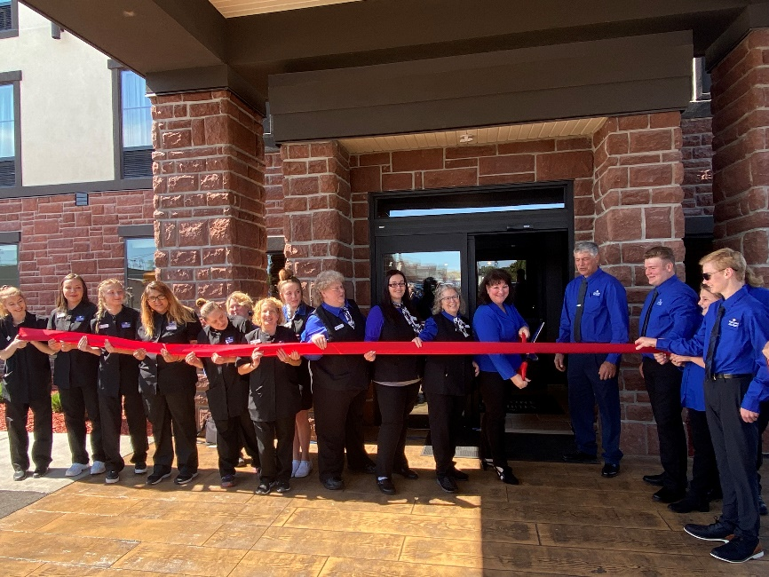
The Cobblestone Hotel & Suites is downtown in the heart of Little Chute next to the well-known Little Chute Windmill at 208 W. Main Street. The four-story hotel has 55 guest rooms, an indoor pool, fitness center, meeting room, and business center.
Nicole Lemens, owner of the Little Chute hotel, gave a heartfelt thank you to the staff of the Cobblestone Hotel & Suites, and echoed other about the importance of the addition of the hotel to the downtown.
“When I think about all of the diligent work this project took; when I think about the strong relationships that have been formed, this truly is a happy and exciting day.” Lemens said.
The hotel additionally features the brand’s consistent amenities such as an onsite convenience store, complimentary high-speed internet access, on-site guest laundry, Seattle’s Best Coffee, and a complimentary breakfast served daily.
Guestrooms are perfectly tailored to meet the needs of modern travelers, while tastefully designed with an element of contemporary elegance. Amenities include flat-screen TVs, additional recharge outlets for electronics, microwaves, mini refrigerators, in-room coffee brewers, hairdryers, iron and ironing boards, desks, luxury linens, and bathroom essentials.
For updates please “like” Cobblestone Hotels on Facebook: https://www.facebook.com/cobblestonehotels/
Whether you are traveling for business or for leisure, you will experience the big city quality, and small town values that each location has to offer. Visit www.CobblestoneHotels.com for reservations or for more information.
About Cobblestone Hotels
Based in Neenah, WI Cobblestone Hotels, LLC is a leading upper-midscale hotel brand with over 160 hotels open, under construction, or in development in 28 states. The company continues to pride itself in filling the lodging needs of communities through its upper mid-scale new build brand. Signature amenities include high-speed Internet access, complimentary breakfast, convenience store, fitness centers, business centers, and more.

Cobblestone Hotels includes Cobblestone Hotels & Suites, Cobblestone Inn & Suites, Boarders Inn & Suites, Centerstone Hotels, and KeyWest Hotels. For development information please visit www.CobblestoneFranchising.com.

Cobblestone Hotels offers the Cobblestone Rewards frequent stayer program where guests receive ten points for every dollar spent, and can be redeemed as award nights, or with other redemption partners. For more information visit www.CobblestoneRewards.com

Contact: marketing@staycobblestone.com

